Installation of IR under Windows Vista
Installation of IR under windows vista involves the following steps:
- Installation of IIS
- Installation of IR runtime
- Configuration of IIS

- Installation of IIS under windows vista is under the Programs and Features\Turn Windows features on or off in the control panel. Open the Control Panel, select Programs. Under Programs and Features, click Turn Windows features on or off. You will require administration privileges for this.
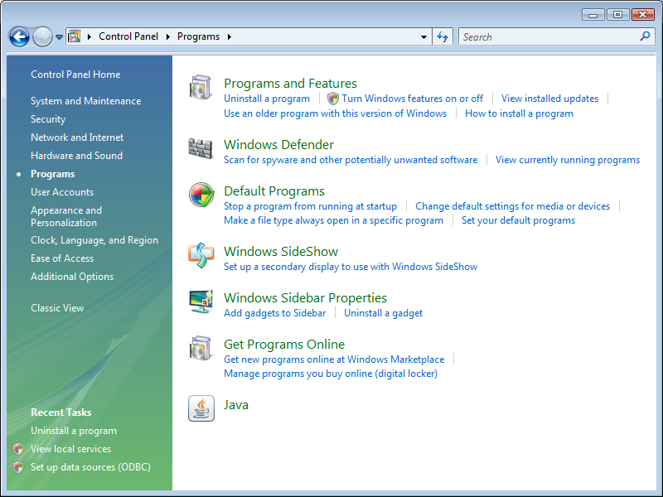
Once the Windows Features window is displayed, click on the ‘Internet Information Services’ checkbox. By default, not all options are selected:
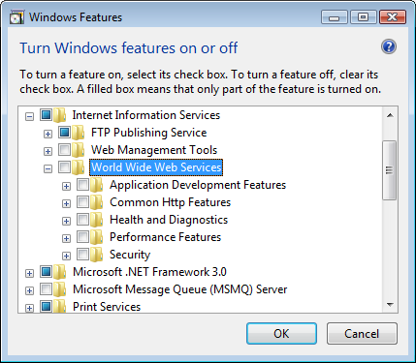
At the minimum, the following features MUST be installed:
- World Wide Web Services\Application Development Features\ASP
- World Wide Web Services\Application Development Features\ISAPI Extensions
- World Wide Web Services\Security\Basic Authentication
- World Wide Web Services\Security\Client Certificate Mapping Authentication
- World Wide Web Services\Security\Digest Authentication
- World Wide Web Services\Security\Windows Authentication

- Download IR (IIS Version Build) from the Interactive Reporting website. There may be different language versions there, so download your native language.
http://www.interactivereporting.com/v32/
http://www.interactivereporting.com/v33/

- A file iis32.zip / iis33.zip will be downloaded. Unblock the zip file by right clicking on the file, clicking unblock and apply. Extract the contents of the zip file to the local C:\ by right clicking it and selecting Extract All.
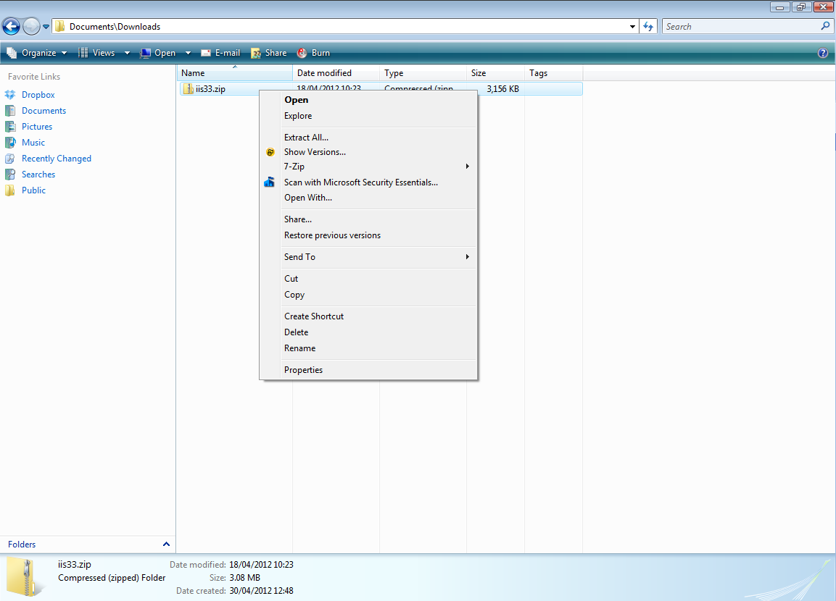

- Choose or type C:\ in the destination box and click Extract.
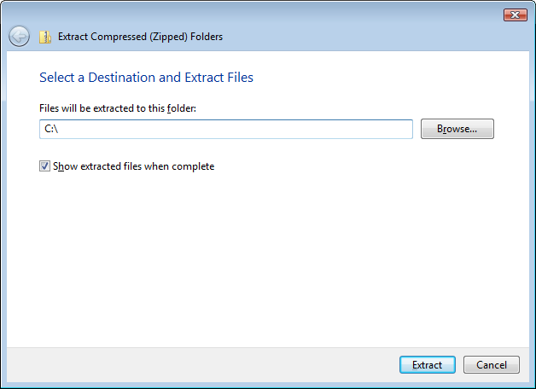

- Navigate to the c:\ir_for_iis32 or c:\ir_for_iis33 folder and right click on setup_dlls.bat and run it as administrator.
(Tech Detail: This batch file will then setup a 32 bit dsn called ir_system32 or ir_system33, and set Read and Write permissions to the ir_data folder for all users, and register the DLLs that IR Uses.)

- When running the Batch File you will be asked whether you want to configure the webserver. If you answer Y, it will setup an application in IIS called IR32 or IR33 on the “Default Website”. It will create a desktop shortcut to access IR. Or you use your internet browser to navigating to
http://localhost/ir32
http://localhost/ir33

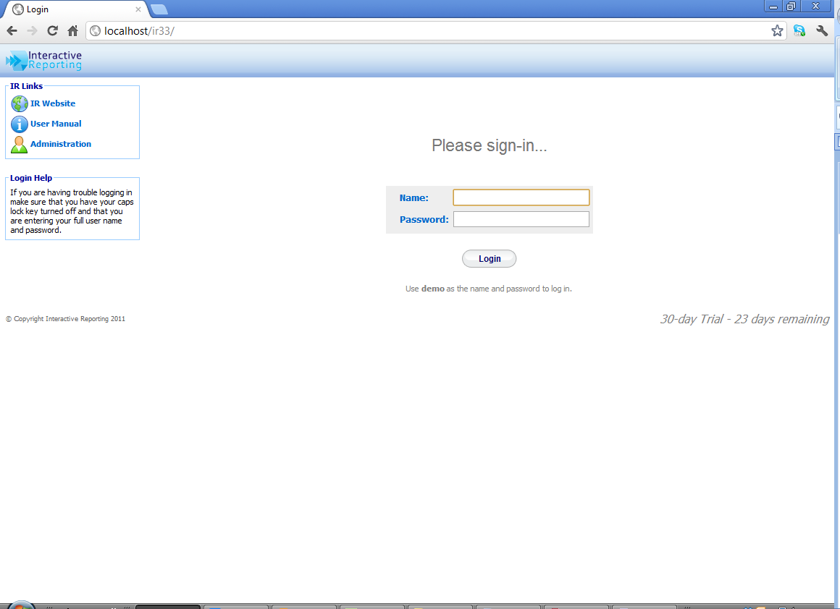

- If you wish to Configure the webserver manually please refer to the document “Setup IR in IIS 7/IIS 7.5 document”.

