To Install IIS On Windows 2012

Configure and Install IIS from Scratch

- Launch Server Manager


- Click on the Manage, and then select Add Role and Features.

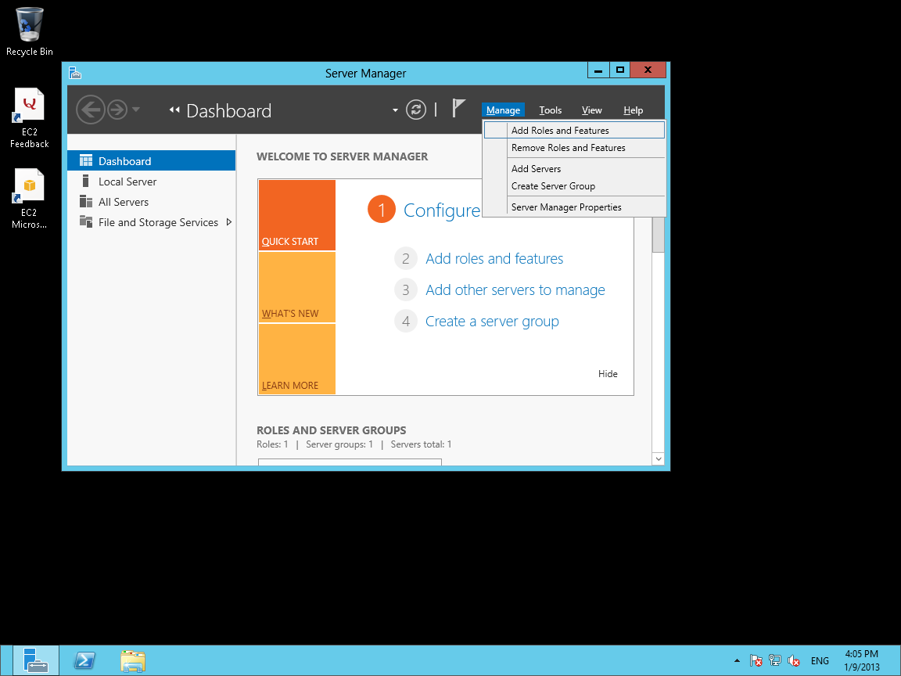

- This Initial information dialog may appear. Press Next
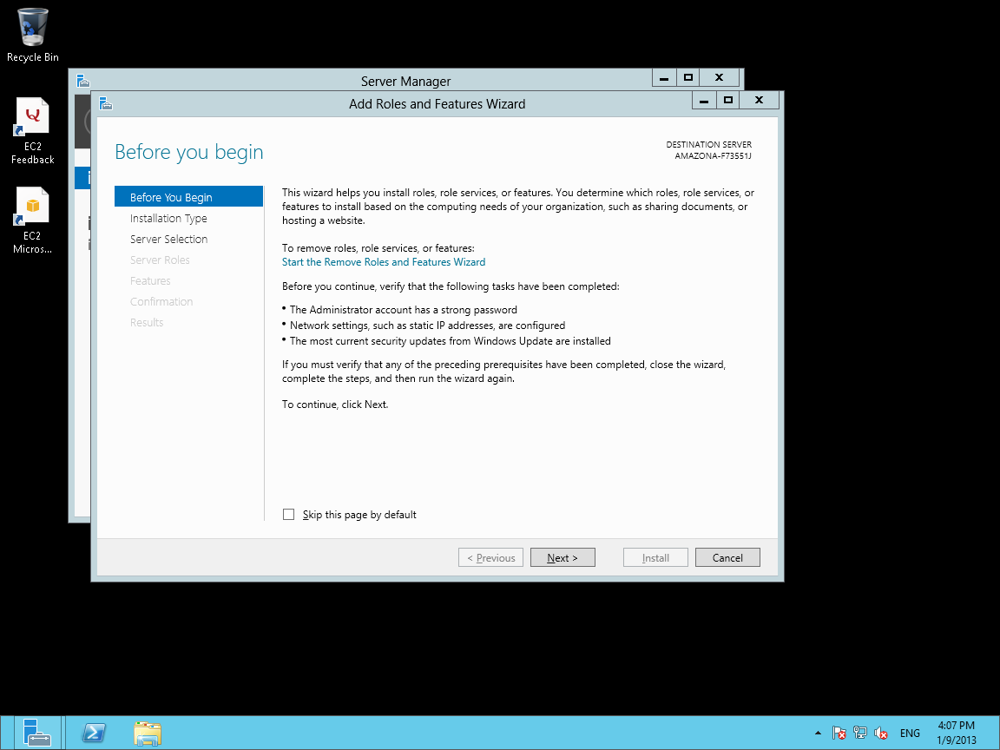

- On the next screen select "Role-base or feature based Installation" and press Next
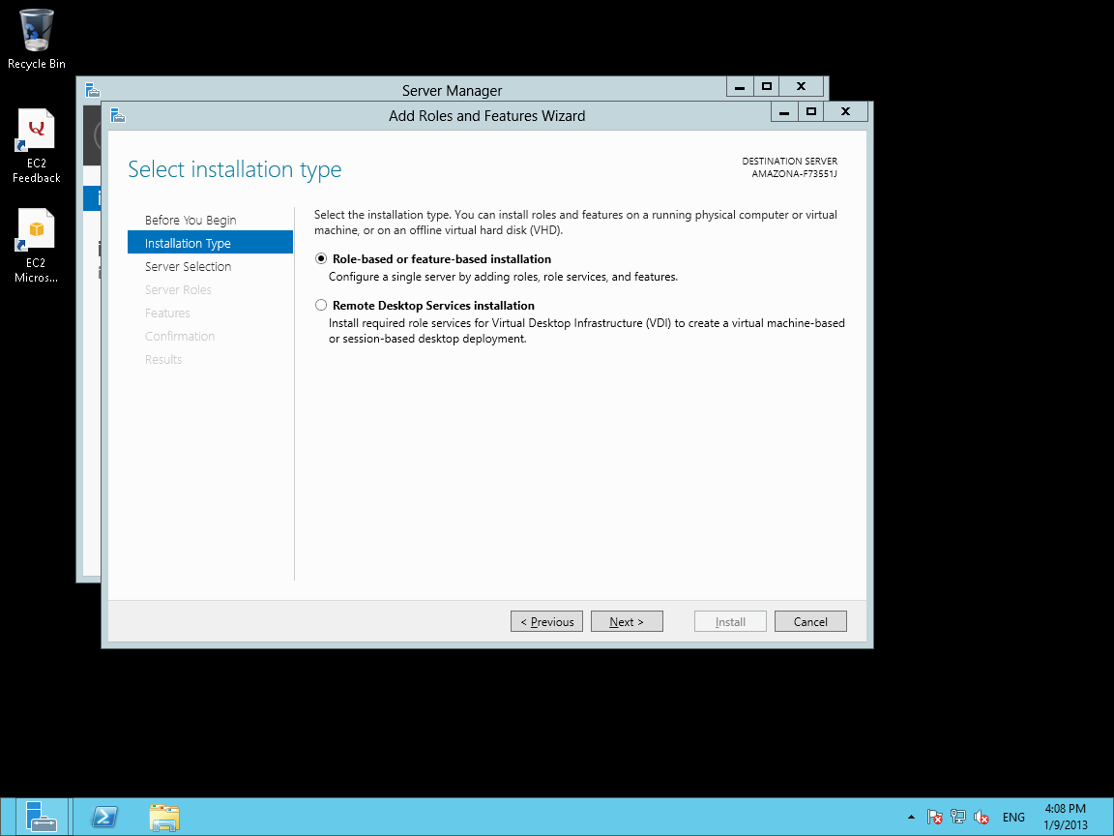

- Select the current local server you want to configure, and press Next
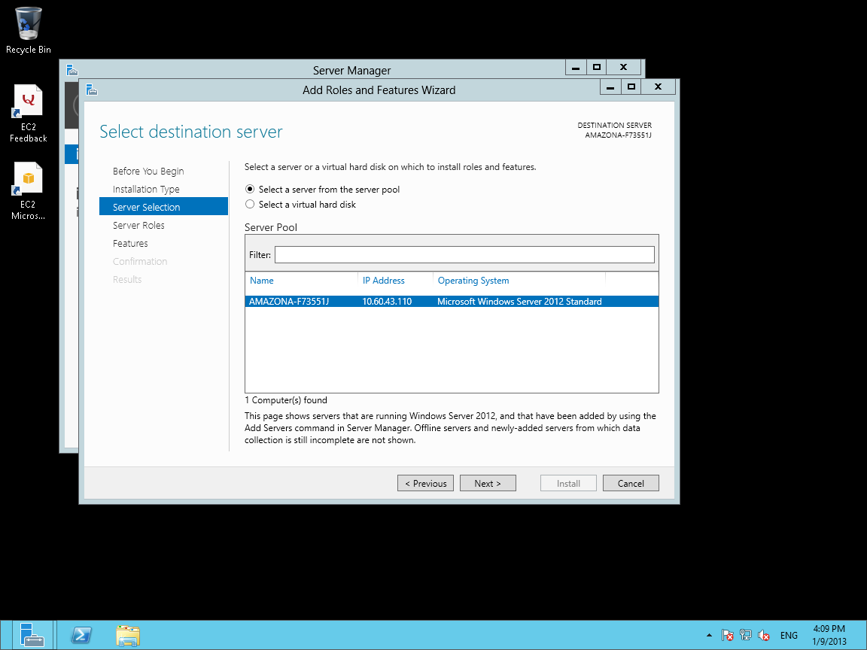

- Select the Web Server Role, by checking the box in front of it, and press Next,
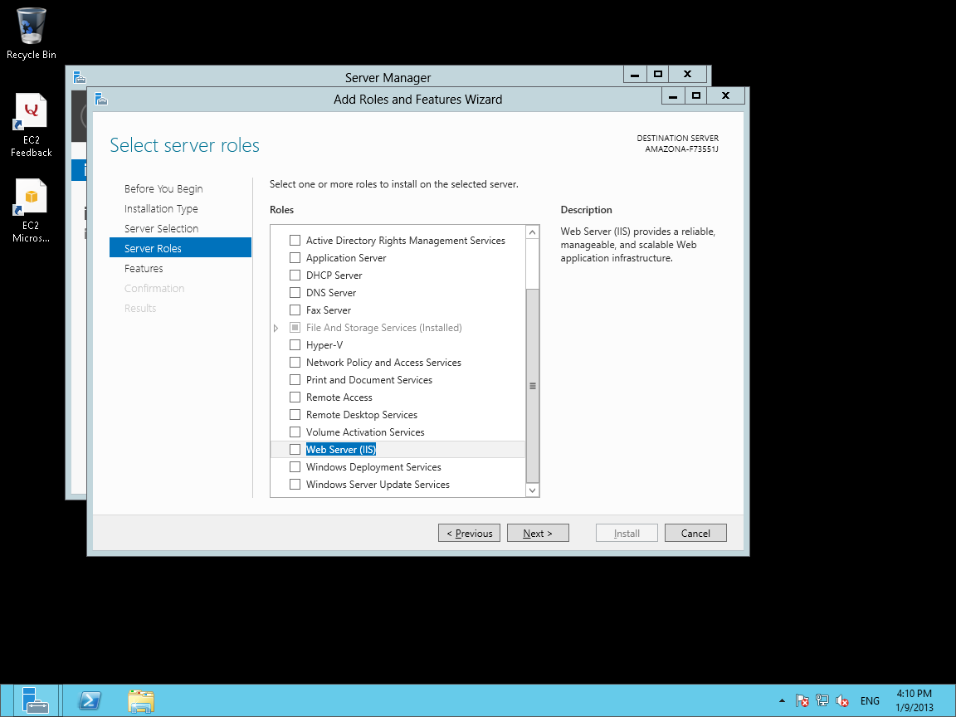

- This dialog box may appear. Press the Add Features

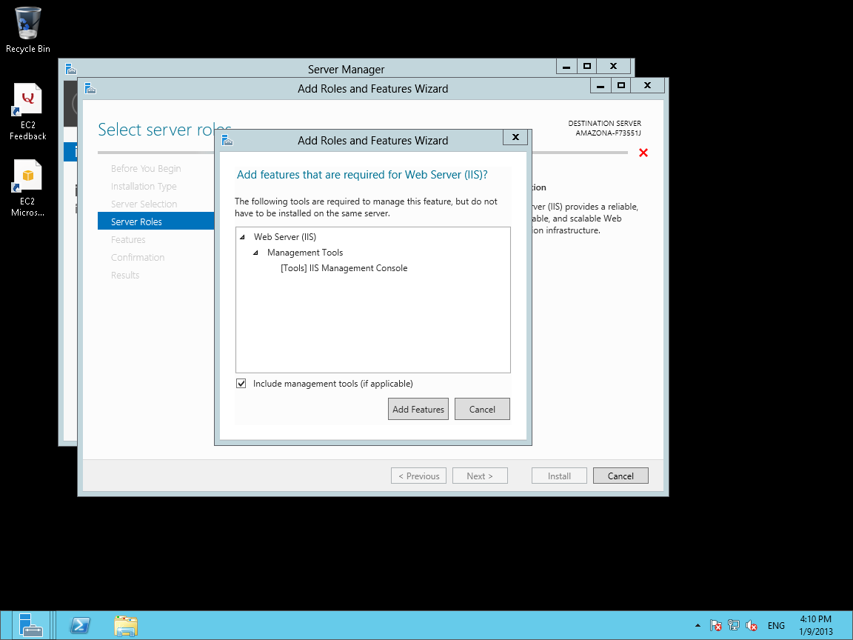

- Now the screen will look like this, with the checkbox check in front of Web Server ( IIS) . Now press Next
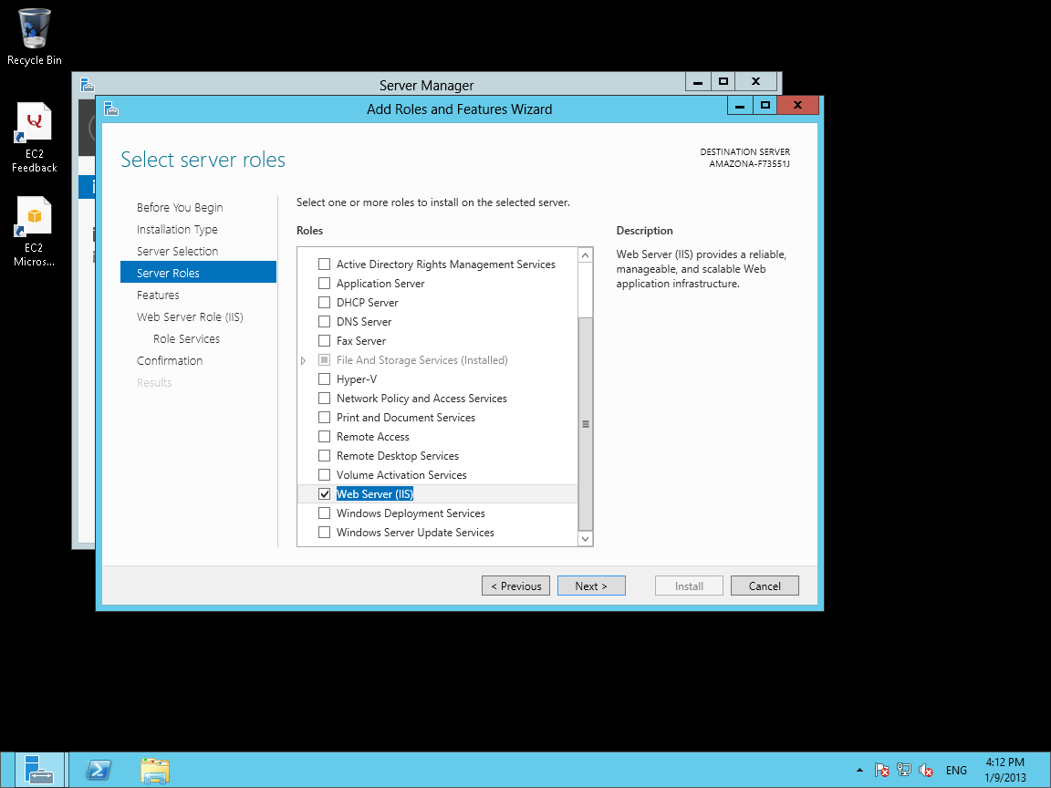

- This screen willappear, to select Features. Just press Next, as you should not need to install any new Features.
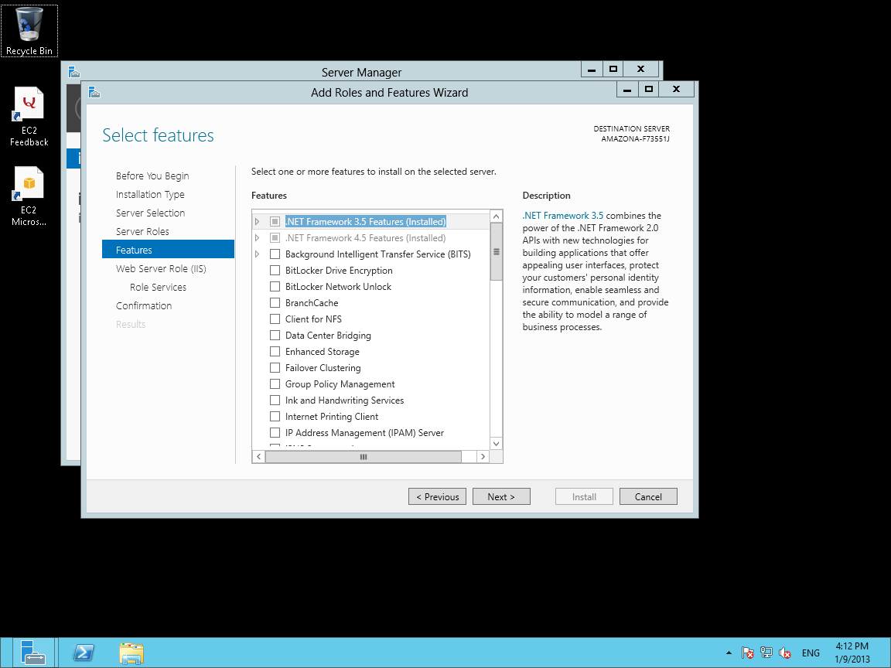

- This dialog will appear to select the specific role services we want. Press Next
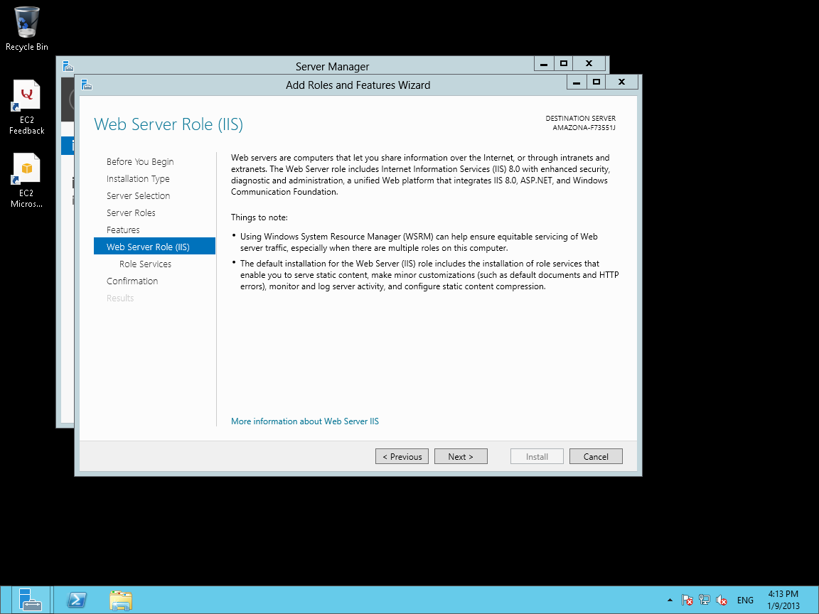

- You will now see a series of sections with checkboxes.
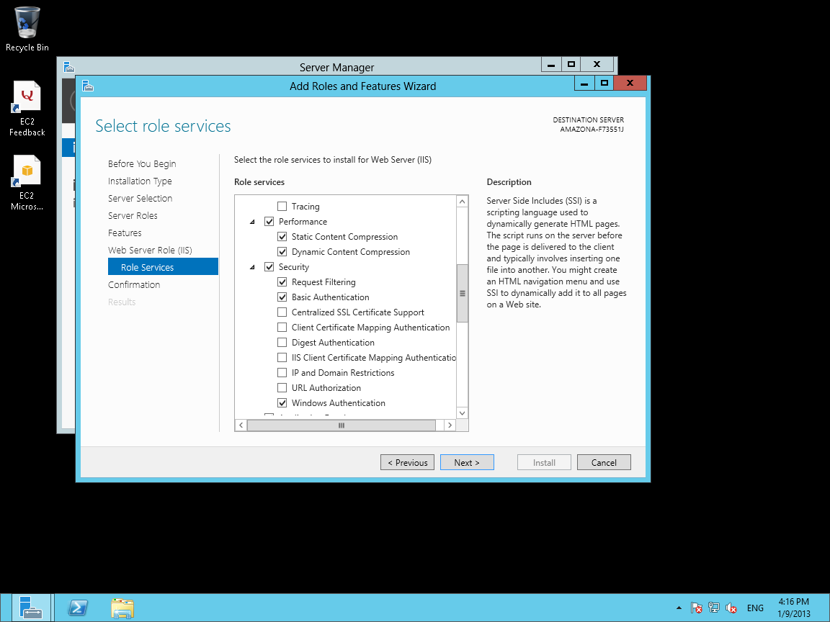

Add the following to the things that are already checked by default. If you are adding to an existing IIS install do NOT uncheck any of the existing checkboxes as these may be required by some of your existing web applications.

Performance/Dynamic Content Compression
Security / Basic Authentication
Security / Windows Authentication

Application Development / ASP
Application Development / ISAPI Extensions
Application Development / Server Side Includes

- The top of the Role Services Dialog for IIS will look something like this in a new Windows 2012 configuration.
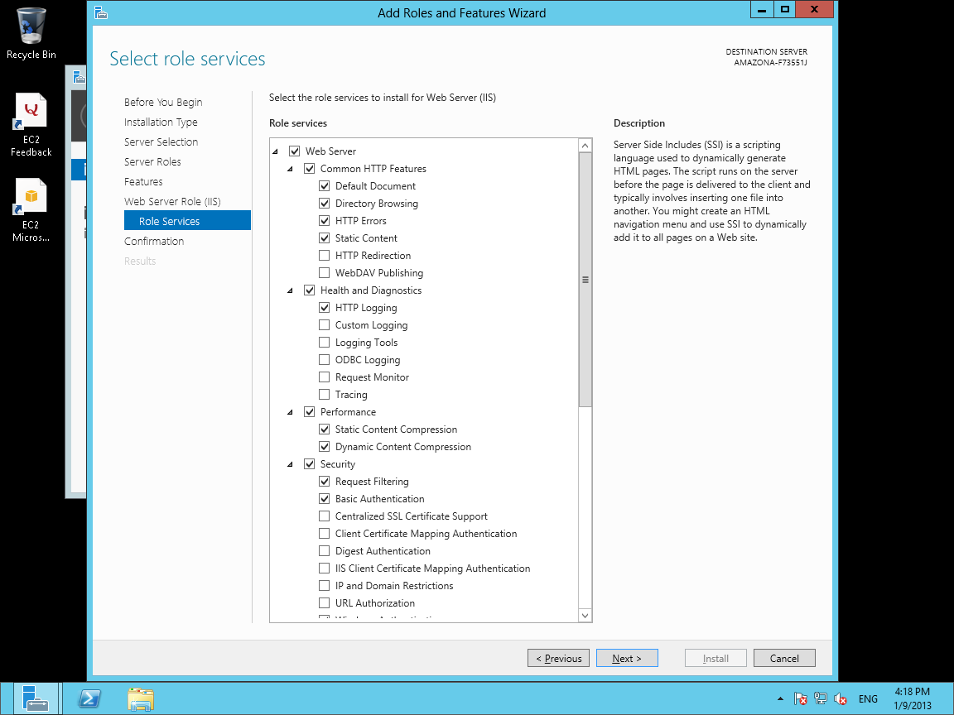

- The Bottom of the Role Services Dialog for IIS will look something like this in a new Windows 2012 configuration. Press Next
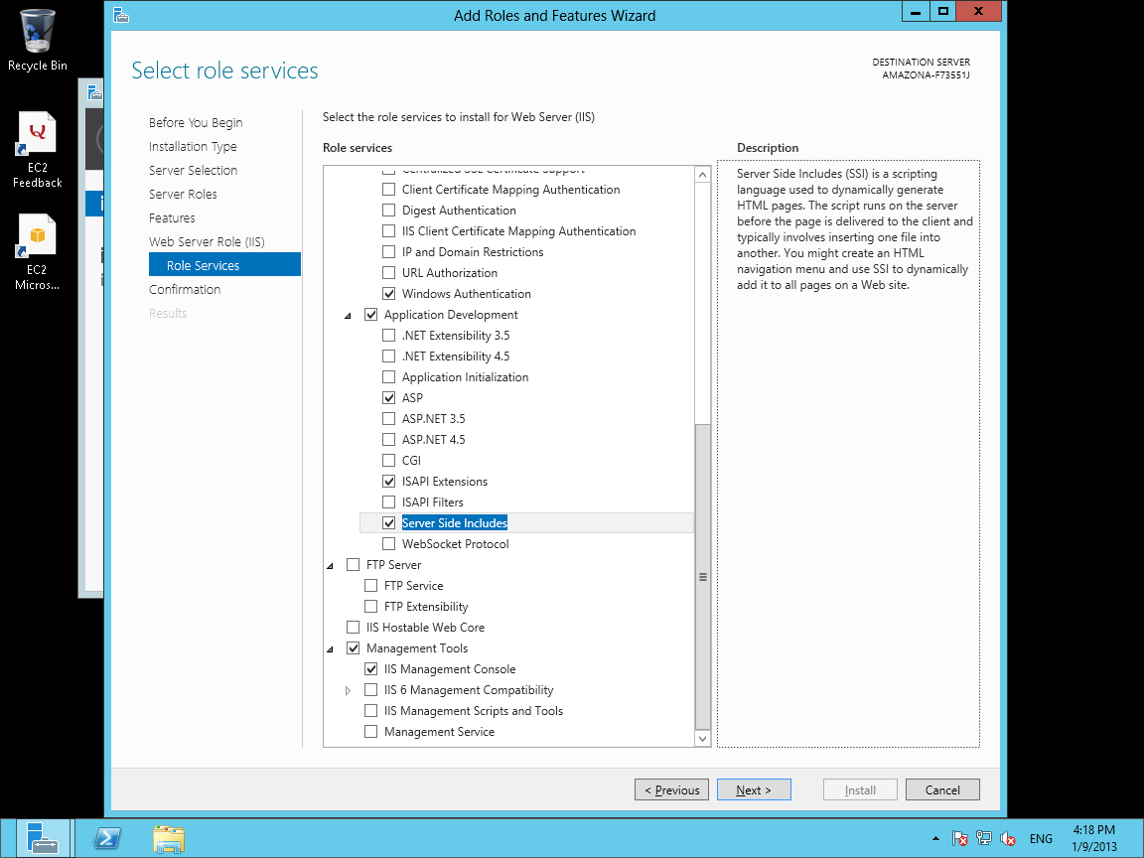

- You will now see this final confirmation screen. Press Install
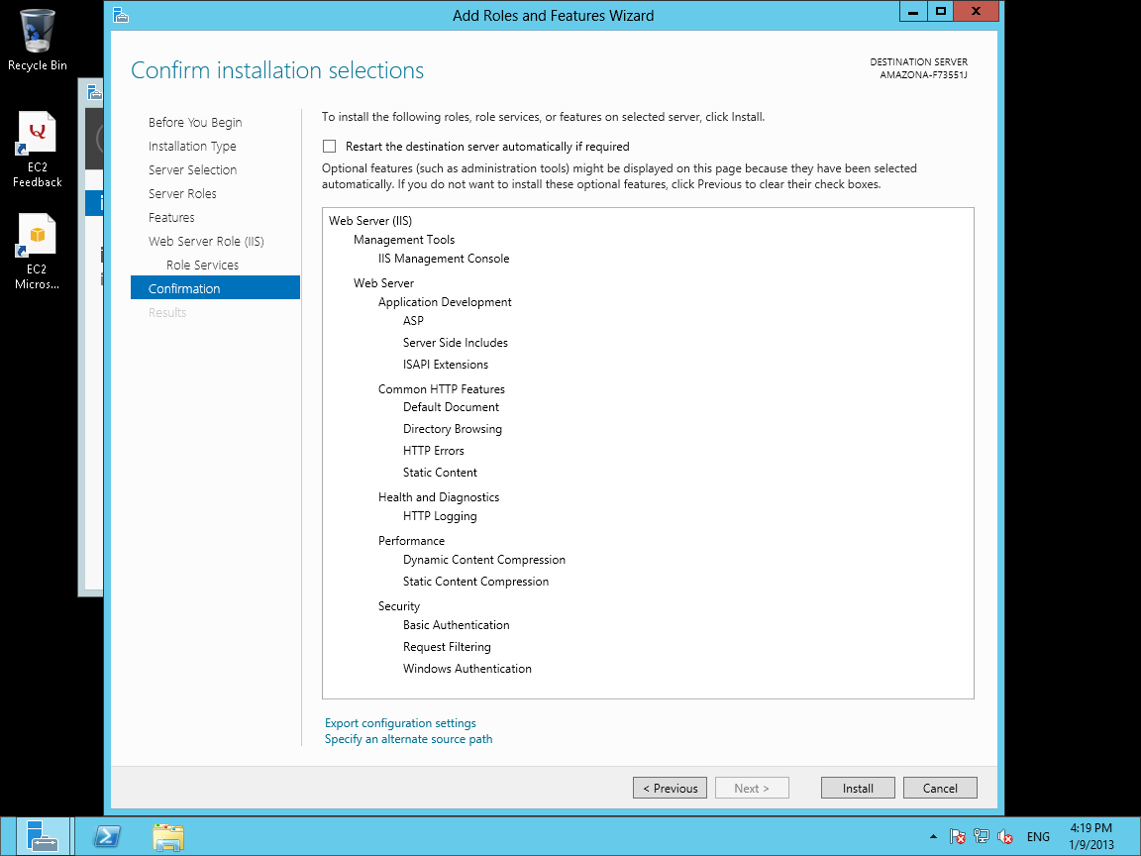

- When Finished Press Close on the Dialog when done

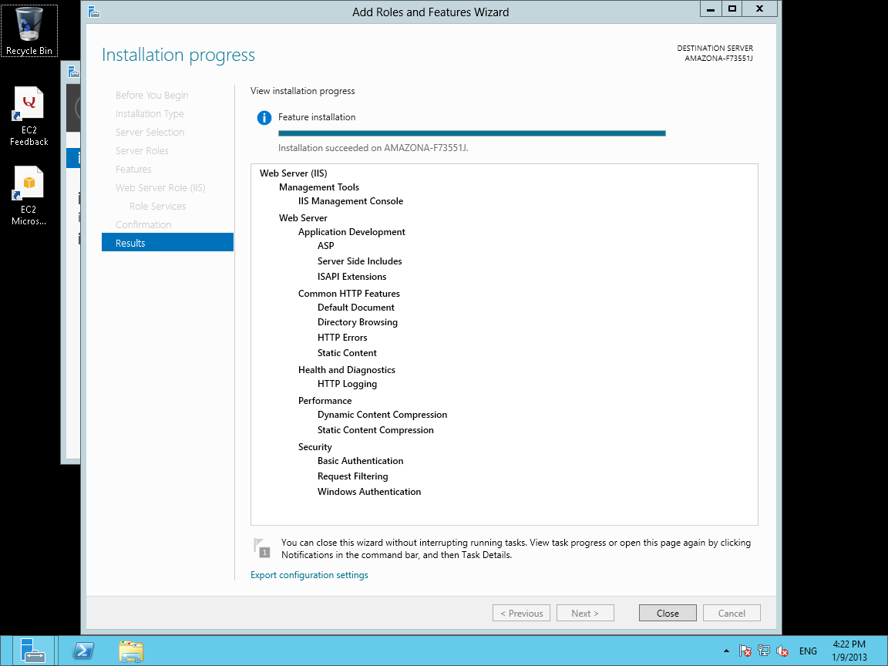

- You will now need to download the latest version of Interactive Reporting 3.3 from www.interactivereporting.com/v33 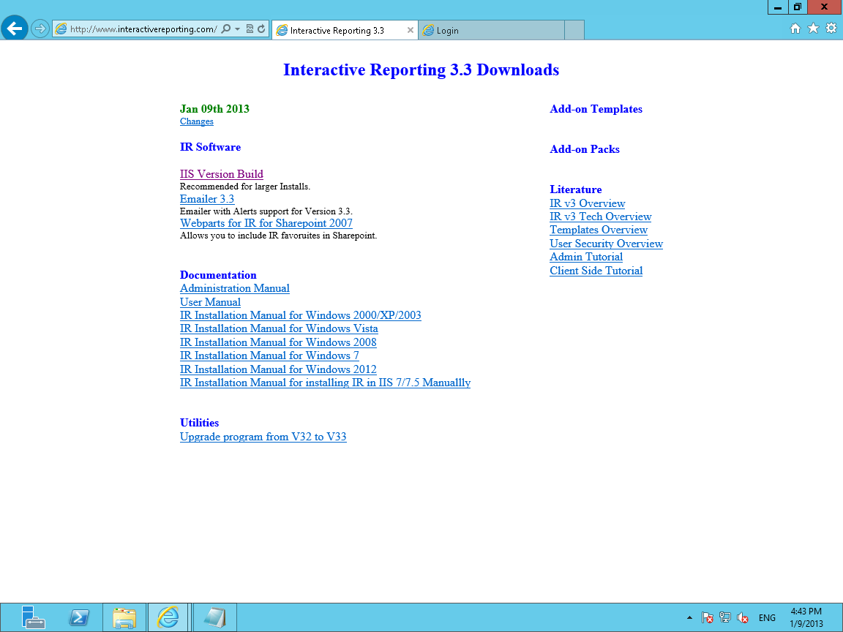

17. You must unblock iis33.zip before extracting the contents. This is done by right clicking on the zip file, tick unblock button and apply.
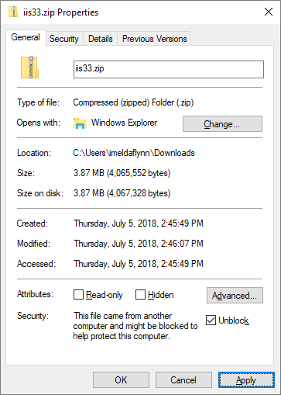

- Next extract the contents of the zip file to the root of the C: drive. You should now see a folder called ir_for_iis33.

- Go into this folder and right click on setupdlls.bat and select Run as Administrator. This will register any relevant DLLs, setup the relevant ODBC data sources.

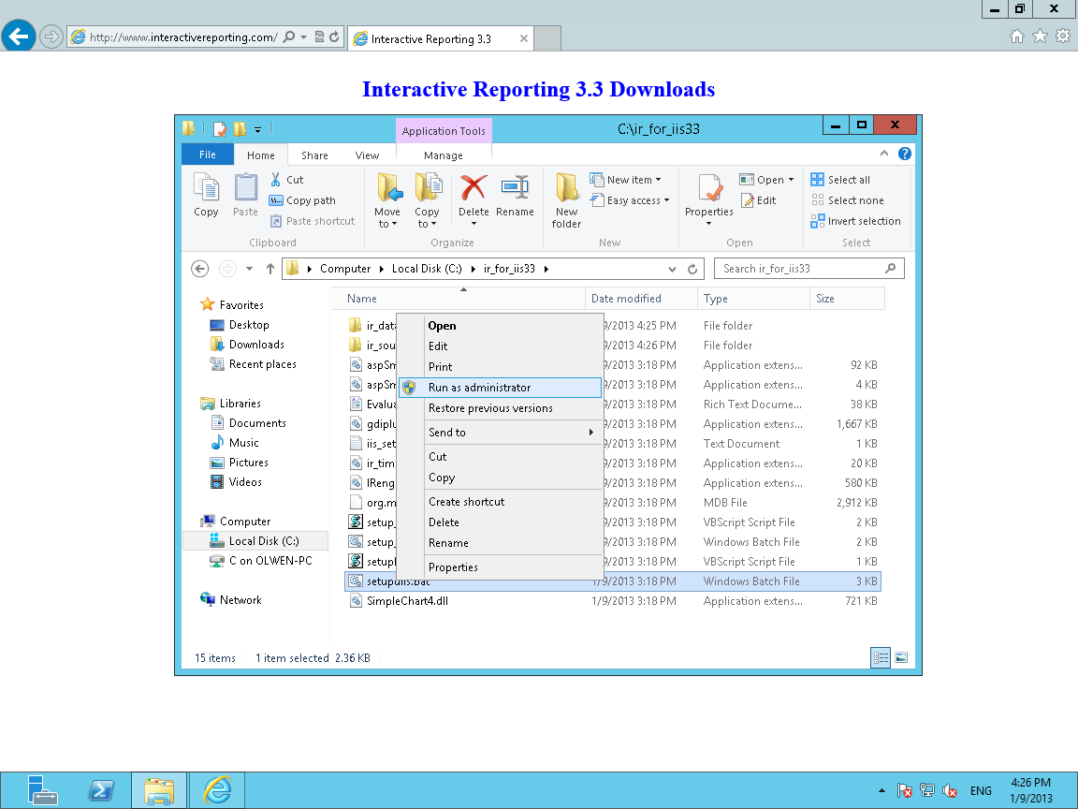

- It will then prompt you if you would like it to add the IR33 Virtual Directory for you to your IIS Install. Press Y, and it will create an application under the default website called ir33 for you.

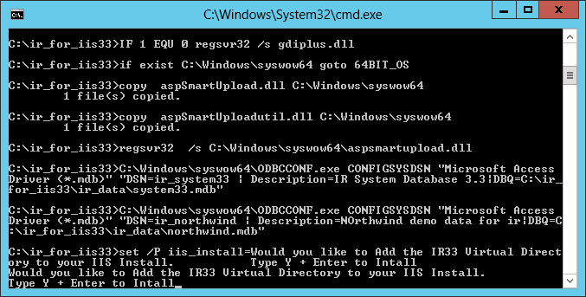

- You can then access the installed web app from either the Desktop Shortcut that is created or from the following URL: http://localhost/ir33

- To configure IIS manually please see our Manual IIS 7 configuration manual

