IIS Install for Interactive Reporting 3.2/3.3 on Windows 2008
The user needs to be a member of the Administrator(s) Group to Install IIS
This document shows you how to install IIS from scratch on Windows 2008 / 2008 R2. IF IIS is already installed, then you should make sure that the first 5 options listed in Step 8 are added, and should not uncheck other options as it could effect your other IIS Apps
We currently do not recommend installing IR on a machine with 64 bit Microsoft Exchange, as we have found there are resulting Bitness issues, that are difficult to troubleshoot.
Configure and Install IIS from Scratch
- Right Click on Computer and Select Manage to bring up Server Manager
- Right click on Roles and Select Add Roles
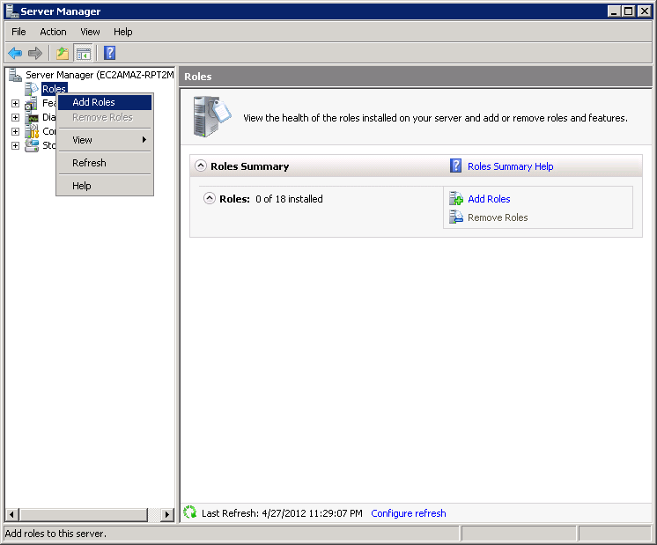
- This will show the Add Roles Wizard. Press Next on this first Screen (if it comes up).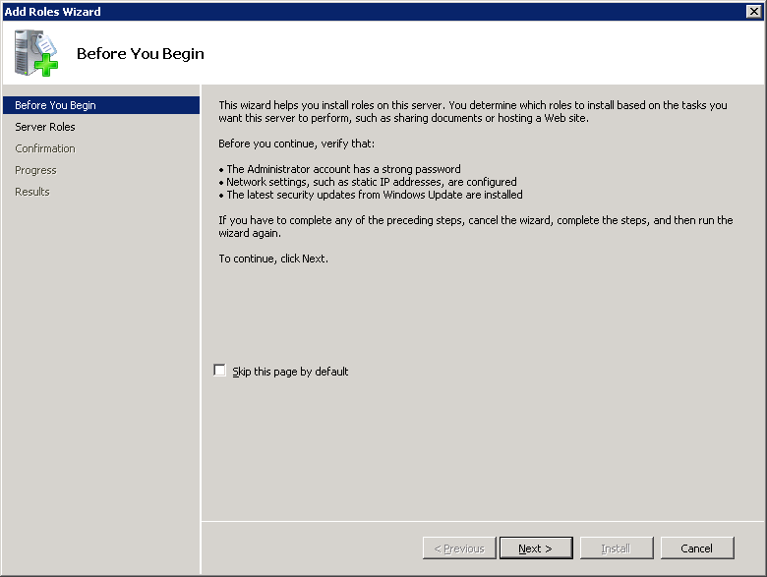

- This dialog for Required Features may also appear. Press Add Required Features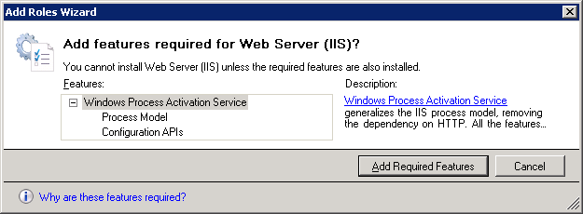
- The Add Server Roles Dialog should then appear like this. Press Next>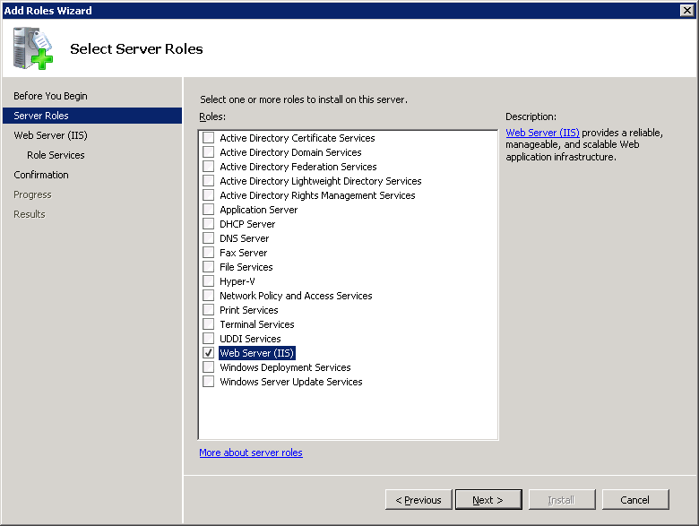
- Press Next> 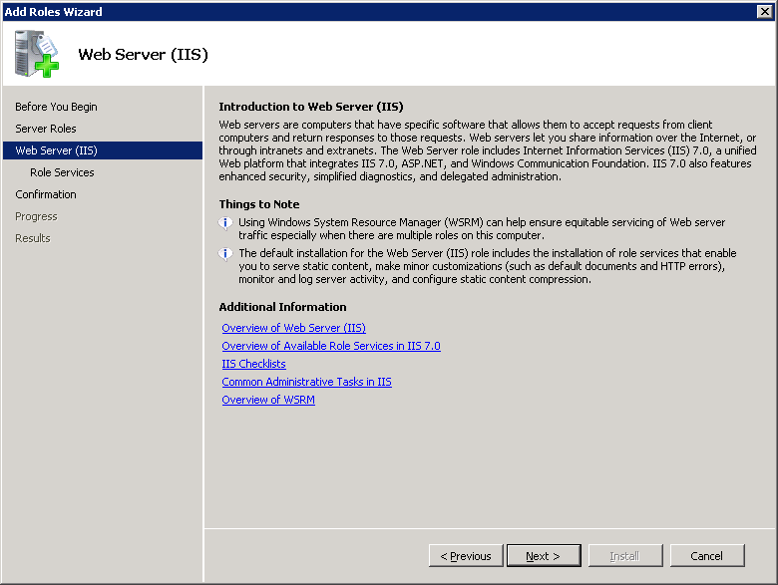
- On the Select Role Services Screen, you will need to add the following Role Services by checking the checkbox in front of each:
Web Server \ Application Development \ ASP
Web Server \ Application Development \ ISAPI Extensions
Web Server \ Application Development \ Server Side Includes
Web Server \ Security\Basic Authentication
Web Server \ Security\Windows Authentication
Web Server \ Performance \Dynamic Content Compression is also useful
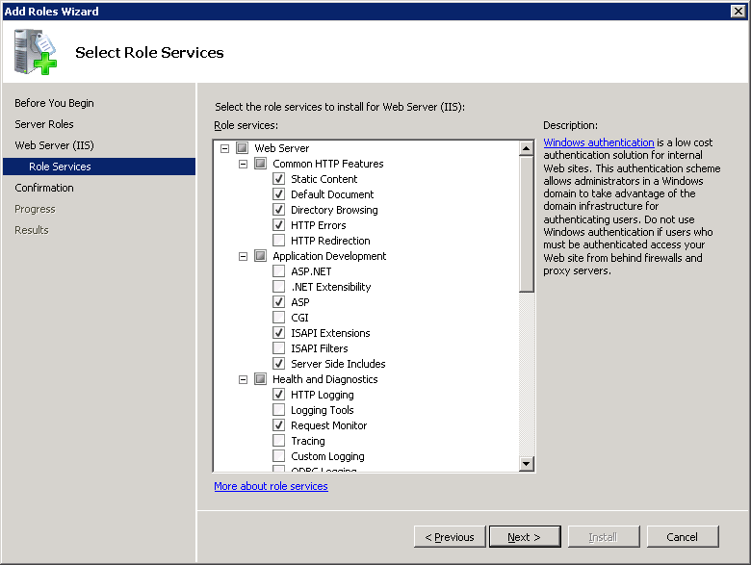
And on scrolling down
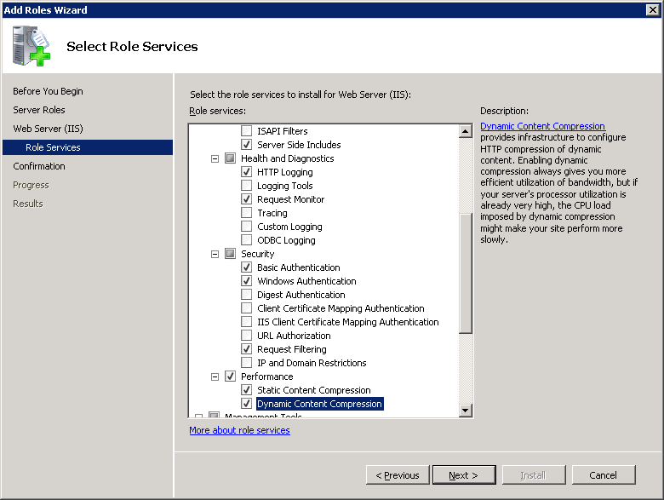
- Press Next >

- In Confirm Installation Selections Press Install
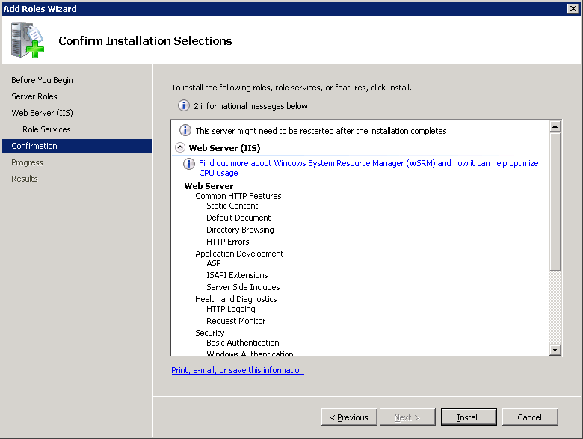
- Press Close.
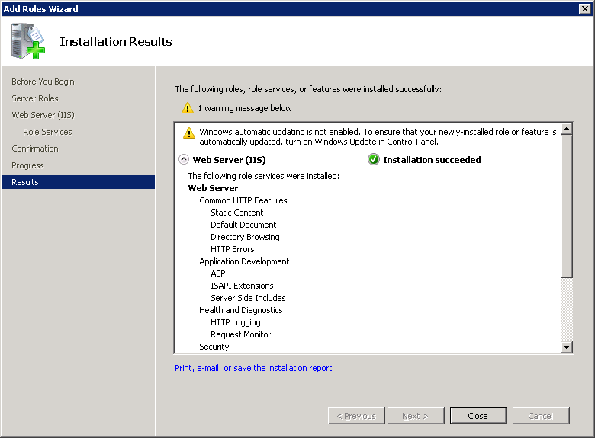

12. You need to download the latest version of IR from the IR website. You want to download the IIS Version Build. There may be different language versions, so download your native language. If you are downloading on the server, IE will prompt you to add www.interactivereporting.com to your list of safe sites.
V32 : www.interactivereporting.com/v32
V33 : www.interactivereporting.com/v33
13. You will download a file called iis32.zip or iis33.zip. Unblock the zip file by right clicking on the file, clicking unblock and apply. Extract the contents of the zip, by clicking ‘Extract All Files’
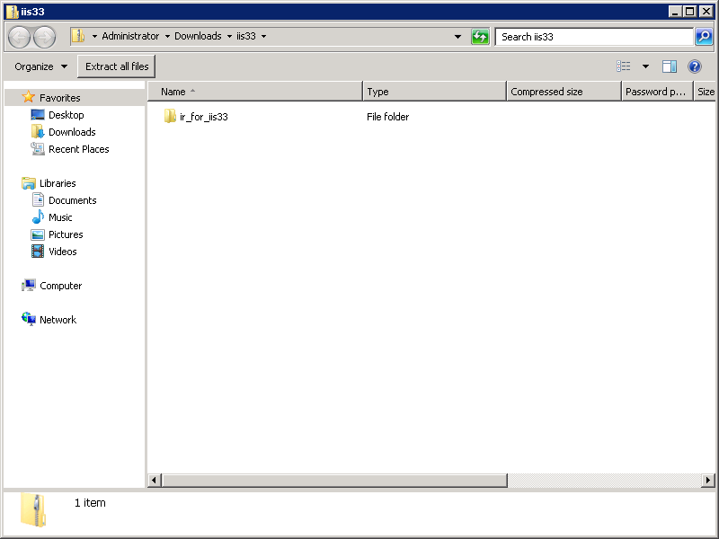
then Enter c:\ as the extract location and click ‘Extract’.
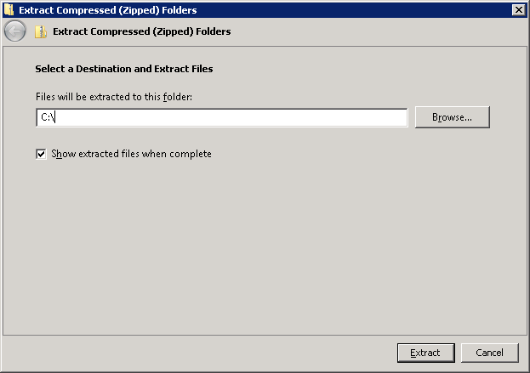

14. Navigate to the c:\ir_for_iis32 or c:\ir_for_iis33 folder and right click on setup_dlls.bat and run it as administrator
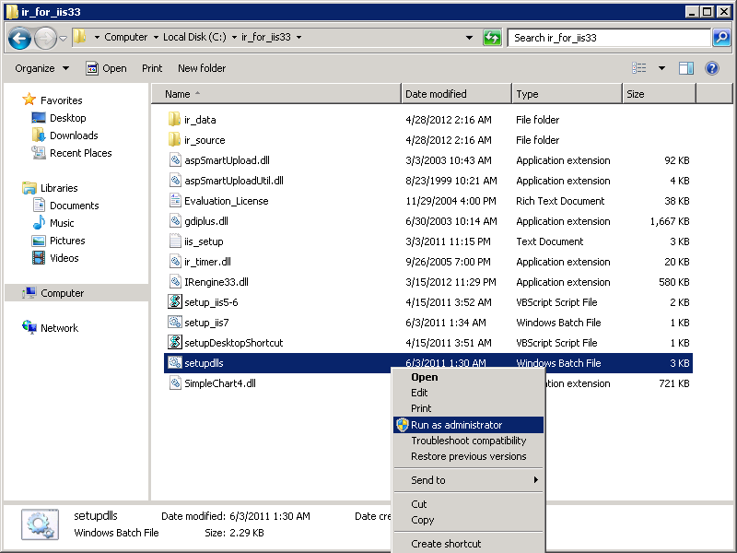
15. In the batch file window it will present a question whether you want to configure the webserver. If you answer Y, it will setup an application in IIS called IR32 or IR33 on the “Default Website”.
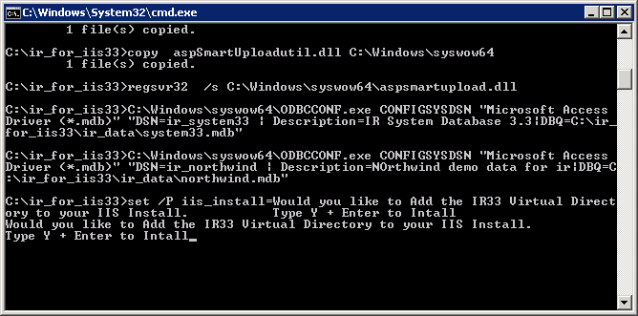
16. A shortcut to IR will be created on your desktop or you can access IR through your browser by navigating to:
http://localhost/ir32 (for v32)
http://localhost/ir33 (for v33)
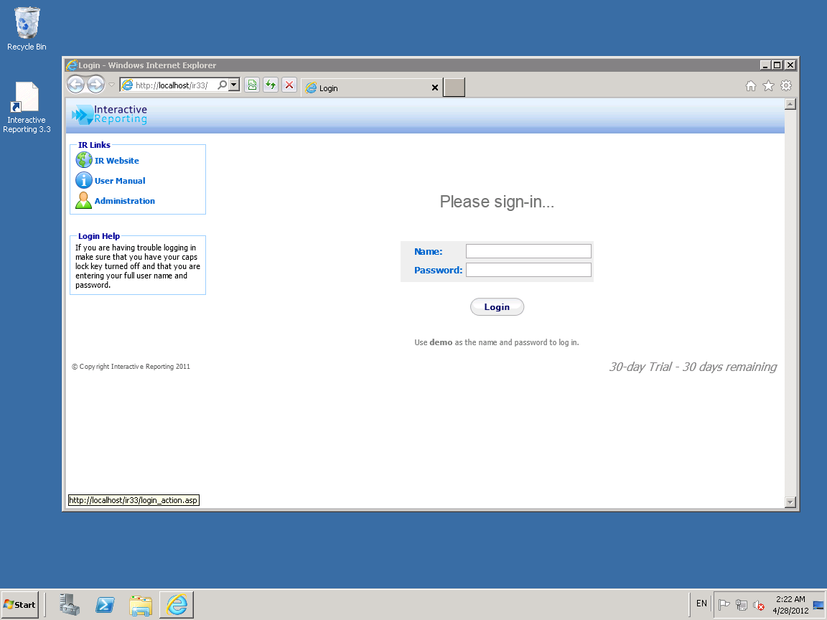

17. To setup IR manually in IIS, see the separate guide for manually configuring IIS 7 / IIS 7.5 and Interactive Reporting.

