IIS SETUP MANUAL
For Interactive Reporting 3.2/3.3

Windows XP
Windows 2000
Windows 2003

General Instructions
Installing on 2000/XP/2003 ( IIS 6).

You will need to have IIS installed and running first.

1. Download iis33.zip from www.interactivereporting.com/v33
2. Unblock the zip file by right clicking on the file, click unblock and apply.
3. Extract the contents of the zip file to the root c: drive. Run setupdlls.bat from the ir_for_iis33 (v33) or Ir_for_iis32(v32) directory, as Administrator. This will configure all the dlls and odbc datasources that IR needs
4. Enter Y when it prompts, for it also to configure IIS, and it will create a virtual directory called ir33 ( v33) or (ir32 for v32) and point it to the ir_source directory

To manually configure IIS, assuming you don't press Y in step 2 Above.

5. Create a virtual directory and point it to the ir_source directory in the ir_for_iis33 folder

Additional Step for IIS
6. On windows 2003
A. make sure that you have enabled "asp pages" and "Server side includes", ( as they are disabled by default )
B. Allow relative path access ( as this is disabled by default )

To Create IR Virtual Directory ( windows 2003 )
Select New Virtual Directory from the IIS Administrator
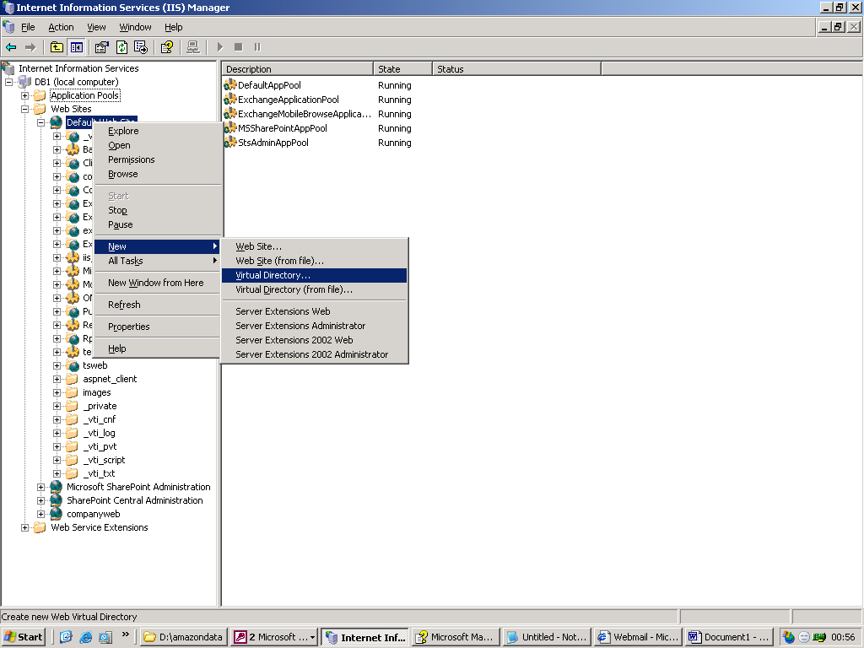

Give It a Name, e.g. IR
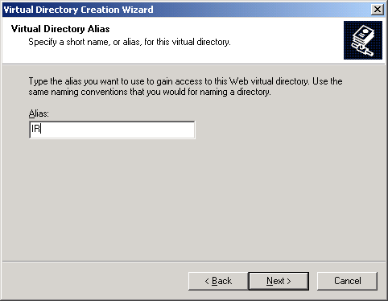

Point it to the IR Source code directory
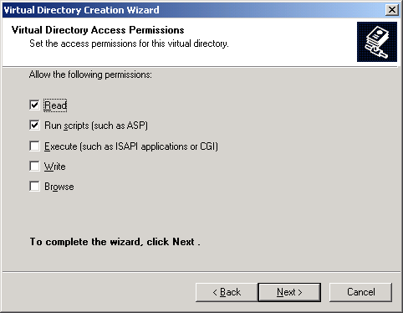

Press Finish


Note by default IR uses index.asp as its home page, but if the default.asp is present, it will redirect correctly to index.asp.

You can add this explicitly to the list of default documents, but this is not required.

To enable ASP pages ( On Windows 2003 only)
1. In IIS Manager, expand the local computer, and then click Web Service Extensions.
2. In the details pane, click Active Server Pages, and then click Allow.

Use “ASP, enabling” as a help index from the windows 2003 help index.
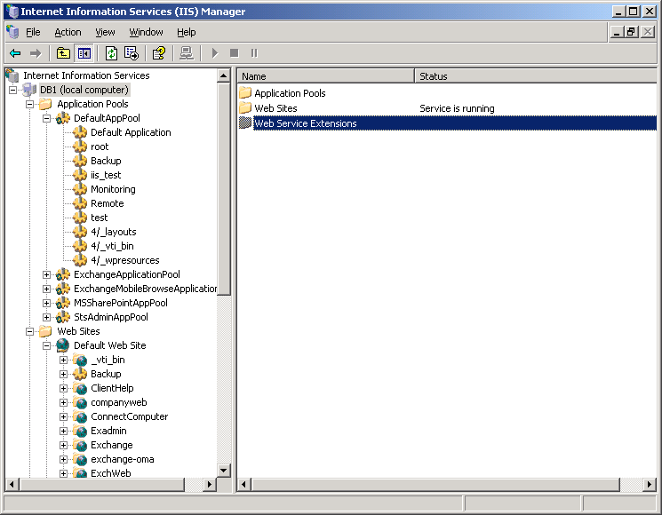

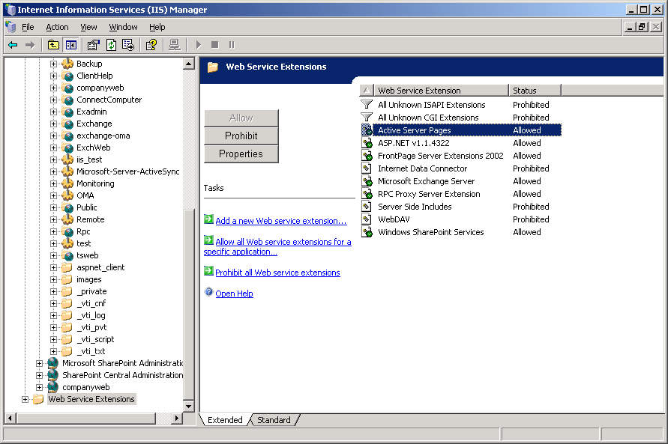

To enable Relative Path Access ( On windows 2003 only )
IR needs to be able to access parent paths in asp pages. This needs to be enabled.
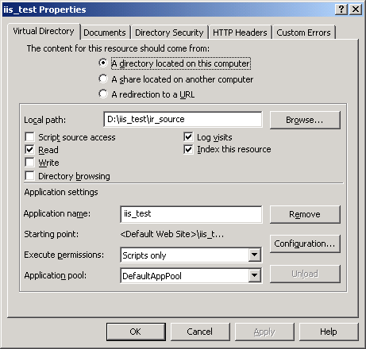

Click on Configuration Button
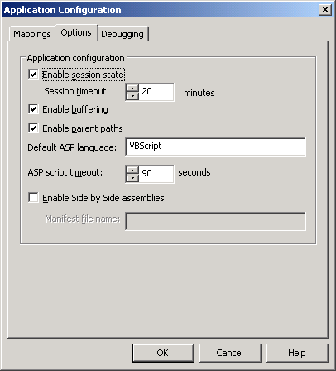
Make Sure Enable Parent Paths is checked

