Interactive Reporting
Volume
1
Sales Analysis and Reporting Products
Interactive Reporting Version 3.2
adMISTRATOR’S GUIDE
Interactive Reporting
Interactive Reporting Administrator’s Guide
© Interactive Reporting Ltd., 2009
1 Great Island Enterprise Park • Ballincollig • Cork
Phone +353-21-4850455 • Fax +353-21-4850454 • Web http://www.interactivereporting.com
Table of Contents
System Requirements 4
Installation 5
Default Username and Password 5
Administration 6
Mapping Data Sources 9
Import a Mapping 10
Create New Mapping 11
Main Transaction Table 13
Map Transaction Fields 15
Edit Mapping 19
Mapping Preferences 22
Security 25
Preview 26
Template 29
Import a Template 30
Create New Template 32
Variables 33
Calculated Variables 34
Lookups 36
Reports 38
Edit Template 39
User Management 42
Add New User 43
Add New Group 46
Edit User/Group 47
Categories 48
System Settings 49
General 50
User Security 51
Email 51
Preferences 52
Look and Feel 55
Interactive Reporting Tools 57
SQL vs Mapping 57
SQL vs ODBC 59
Datapump 60
Installation & Removal of IR Service 64
Standalone Interactive Reporting 64
Service Interactive Reporting 64
Sample.css 66
Performance Optimisation 71
Setting-up a Data Warehouse 72
Analysing Other Types of Information 74

Chapter
1
System Requirements

What You Must Already Have…

You must be using one of the following operating systems:

- Windows 98/Me
- Windows NT 4.0 Workstation
- Windows NT 4.0 Server
- Windows 2000 Pro
- Windows 2000 Server
- Windows 2000 Advanced Server
- Windows XP Pro & XP Home
- Windows 2003
- Windows Vista
Installation
Chapter
2
Getting Interactive Reporting on to the system…
D
ownload the installable execute, click on it and follow the instructions.

Default Username and Password
The default user name is demo and the default password is demo.

Administration
Chapter
3
Getting Interactive Reporting ready for use…
Administration of Interactive Reporting is performed via the administration console. To access the Admin section, click the ‘Administration’ link on the main Interactive Reporting login page shown in Figure 1. This directs to the Administration Login Page, Figure 2. To login use the default administration password which is demo.

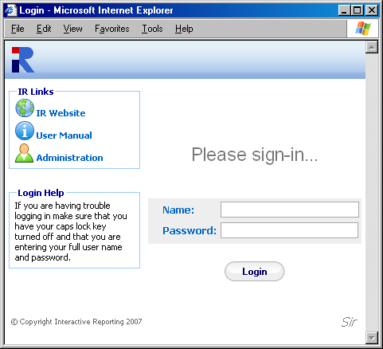
Figure 1

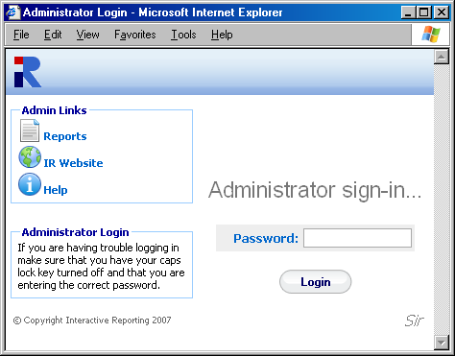
Figure 2

Once logged in, there are a number of options available to the users that are shown at the first page of the administration side, as seen in Figure 3. Each option can be reached by clicking the appropriate link name. These options are:
- Mappings – links to the Mapping Section.
- Templates – links to the Template Section.
- Users and groups – allows the administration of users and groups in the system.
- Favorite Categories – provides a list of categories for favorite reports
- System Settings – contains specific information that facilitates the system’s operation.
- Look and Feel – allows for the customisation of the design of Interactive Reporting
- Back to Report – links to Interactive Reporting Login page (Figure 1).
- Interactive Reporting Web Page – links to Interactive Reporting Home site.
- Help – opens a copy of the Administration Manual.
- Tools – links to different mode SQL and data transfer tools for more Interactive development.

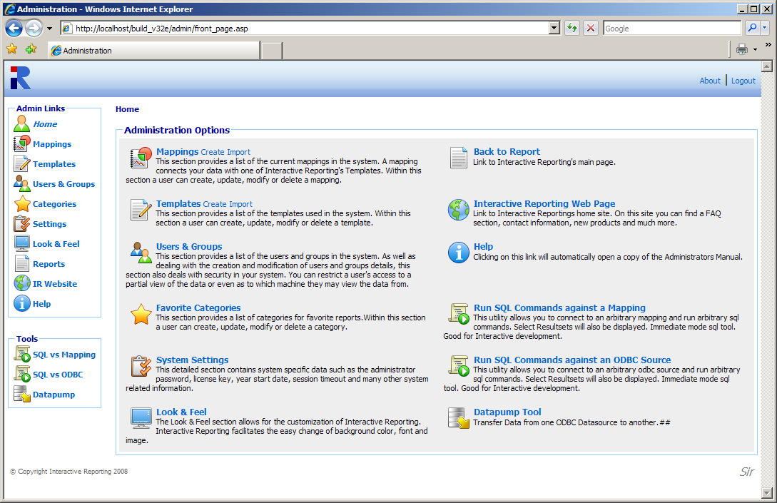
Figure 3

Mapping Data Sources
Chapter
4
How to Create and Operate Mappings Easily…
AMapping connects the User’s Data (source) with one of Interactive Reporting Templates (destination). In this way, data may be accessed in a simple and concise way without the need to deal with database tables and forms.
Mappings can be Created, Edited, Deleted, Cloned, Imported and/or Exported or just viewed. To access the ‘Mappings’ section click on the ‘Mappings’ link of either the ‘Administration Options’ menu or of the ‘Admin Links’ sidebar menu at the left of the page of Figure 3. The user will then get directed to a page like the one shown in Figure 4, which contains a list of all available mappings.

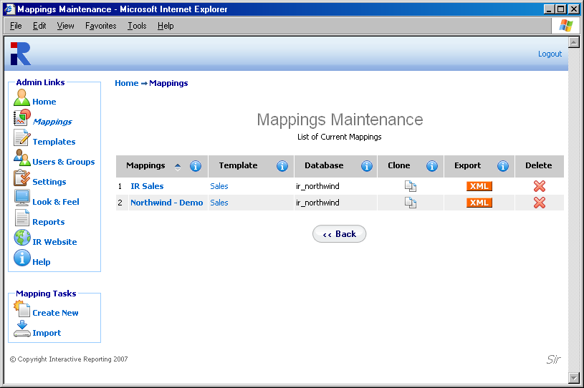
Figure 4

Each Mapping is characterised by a user-friendly name that is shown in the column ‘Mappings’. In Figure 4 there are two mappings, one called IR Sales and one called Northwind – Demo. Clicking the Mapping’s Name Link allows viewing of the mapping details and/or editing the mapping’s options.
- The ‘Template’ Link redirects to the viewing page of the template associated with the mapping.
- The ‘Database’ heading allows the user to see on which database the mapping is based.
- The ‘Clone’ option creates a complete copy of the mapping. Cloning is one Interactive Reporting most powerful tools. This is useful when the user has two very similar databases. Simply clone the first mapping and make the alterations to the cloned one. To Clone a Mapping, click the ‘Clone’ icon next to the mapping of interest. To Export a Mapping, click the ‘Export’ button next to the mapping. This will cause a box to pop up on screen advising the user to also export the associated template. This is important, as a Mapping must always be correlated with a Template - if the associated template does not exist and an import of the mapping is applied, the import will fail. After the user is notified about the template, a second popup box appears that prompts the user to save the mapping to their desired location. To delete a mapping just click the delete icon relevant to the mapping that is no longer required.
In addition to the ‘Admin Links’ and ‘Tools’ options, the mappings maintenance page provides the mapping tasks to create a new mapping and import an existing one.

Import a Mapping
To import a mapping click the ‘Import’ link of the ‘Mapping Tasks’ section on the left side of the mappings maintenance page. The user is then directed to the ‘Import Mapping’ page as can be seen in Figure 5. Before importing the mapping the user should ensure that the associated template is stored in the template section. The user simply enters the path where the stored mapping is located or uses the ‘Browse’ button to locate the mapping if unsure of the destination path. When the destination path is provided click the ‘Import’ button to return to the mappings page. Once the mapping is imported it will appear within the list of available mappings. The system administrator can now give users access to this mapping by setting their access level in the user section.

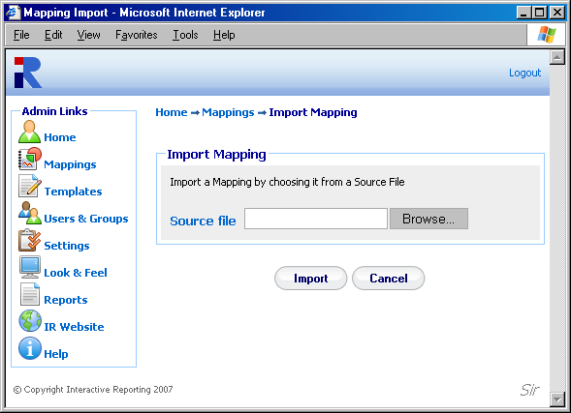Figure 5

Create New Mapping
To create a New Mapping click the ‘Create New’ link of the ‘Mapping Tasks’ section on the left side of the mappings maintenance page. The user is then directed to the ‘Create New Mapping’ page as can be seen in Figure 6. First complete the name to be used for the new mapping. This information is required. Next enter a description of the mapping, note however that this is optional. Choose the associated Template for the new mapping. If the ‘Template’ List is empty or the template of your choice is missing, go to the template section to create the template that suits the new mapping’s requirements. The database type can be chosen from a select list, which includes Oracle, Access, MySQL, SQL Server and many more.
There are two options available to the user for the Database Connection. The ‘DSN’ option provides a list of the system (ODBC) data sources. The user must select one and enter the username and password if applicable.
To use an ODBC data source the user must set the ‘DB’ option. If there is no password, just type in the name of the data source or ODBC connection in the text box provided. If there is a password then the user must enter the following: ‘DSN=NameFromControlPanel;UID=your_username;Password=your_password’.We advise the user to use the DSN set-up.
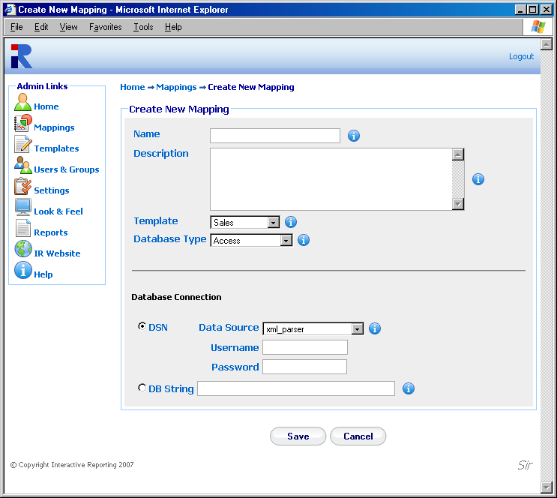
Figure 6

If the ODBC data source has not been set in the ODBC control panel, one of the following options can be used:
- Access: PROVIDER=Microsoft.Jet.OLEDB.4.0; DATASOURCE=c:\mydatastore\mydatabase.mdb
- SQL Server: PROVIDER=SQLOLEDB; DATA SOURCE=myServerName; INITIAL CATALOG=myDatabaseName;
USER ID = myUsername;PASSWORD=myPassword
- Oracle PROVIDER= OraOLEDB.Oracle; DATASOURCE = YourTNSName; USER =johns; PASSWORD = johns;

Interactive Reporting has been tested against Access 97, 200, XP 2003, SQL Server 7,2000. For MySQL install MyODBC. Set-up an odbc Datasource in the control panel to the MySQL database. Interactive Reporting has been tested against MySQL 4,3.23. Interactive Reporting only works with the ORACLE ODBC Driver. Always use Oracle drivers and not Microsoft ones. This has been tested against Oracle8i, 9i and 10j. For Informix, the Informix CDSK must be installed to have access to the Informix Drivers. This has been tested against Informix 7.2.x.

When finished with setting all the options for generating the new mapping’s database connection, click the ‘Save’ button to generate the new mapping. The user then is directed to a screen like the one shown at Figure 7, where they can proceed with mapping the main transaction table.

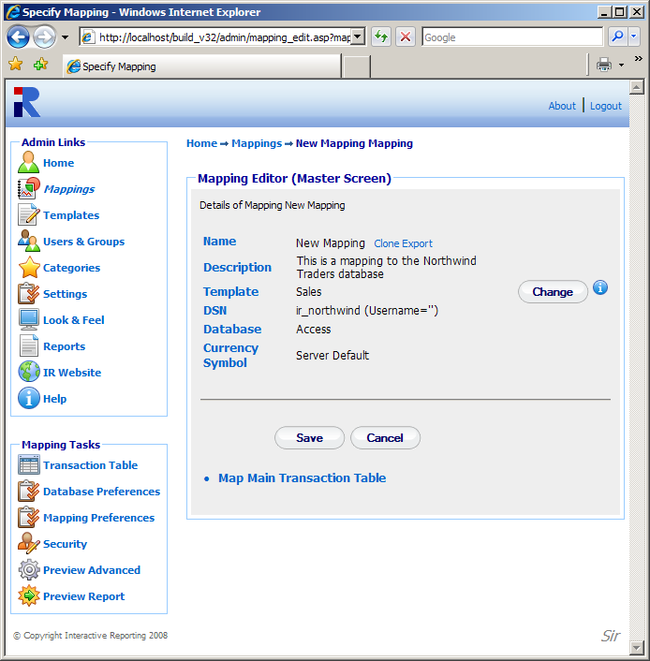
Figure 7

Main Transaction Table
To map the main transaction table, the user must click the link ‘Map Main Transaction Table’ of Figure 7, or the sidebar option ‘Transaction Table’ of the ‘Mapping Tasks’ menu. The user will then go to the first page of the Mapping Editor, Figure 8.

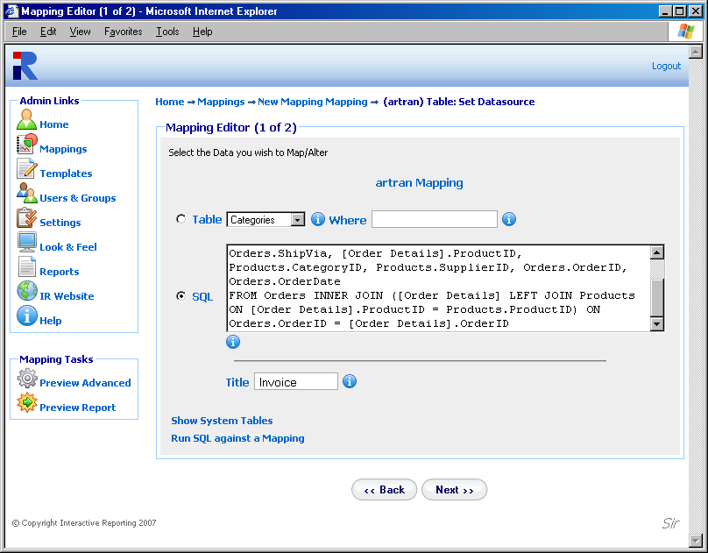
Figure 8

The fields in the main transaction table become visible either by selecting the table in which they are found or by specifying an SQL statement that collects the required fields from the mapped data source. To choose between the table and the SQL statement, click the appropriate radio button.
The ‘Table’ list contains the tables that are available in the data source that the user is trying to map. The user can select from this list the table that contains all the fields that correspond to the main transactions. If there are constraints to be imposed, these may be performed within the ‘WHERE’ field using an SQL-syntax. For example, entering ‘invoice_transactions.qty=1’ would choose only those invoice entries where only a single item was sold.
The ‘SQL’ option is more suitable for advanced users. If the information to encapsulate an invoice the user needs is not directly available within a single table, i.e. it either needs to be calculated or is split across several tables, then an SQL statement may be entered, which directly extracts that information. For example, if the system operates on the basis of price-codes, with a table provided for the lookup of the corresponding price, we may calculate the relevant price for each line on an invoice with the following SQL statement:
‘SELECT *, price FROM pricecodes, invoice_transactions WHERE invoice_transactions.pricecode=pricecodes.code’.
For the Northwind example use the following SELECT statement:
‘SELECT 2.0 as currency_factor, [order details].UnitPrice AS unit_price, [Order Details].Quantity, [Order Details]. costprice,Orders.CustomerID,Orders.EmployeeID, Orders.ShipVia,[Order Details].ProductID, Products. CategoryID,Products.SupplierID,Orders.OrderID,Orders. OrderDate FROM Orders INNER JOIN ([Order Details] LEFT JOIN Products ON [Order Details].ProductID = Products.ProductID) ON Orders.OrderID = [Order Details].OrderID’
N.B. The user should use this mechanism to exclude voided transactions from any of Interactive Reporting reports.
When finished the user must click the ‘Next’ button to proceed with the mapping of the individual transaction fields. The user will then go to second page of the mapping editor of Figure 9, where they can select which elements of the main transaction table are of interest to their report and connect them to the appropriate template Interactive Reporting fields.

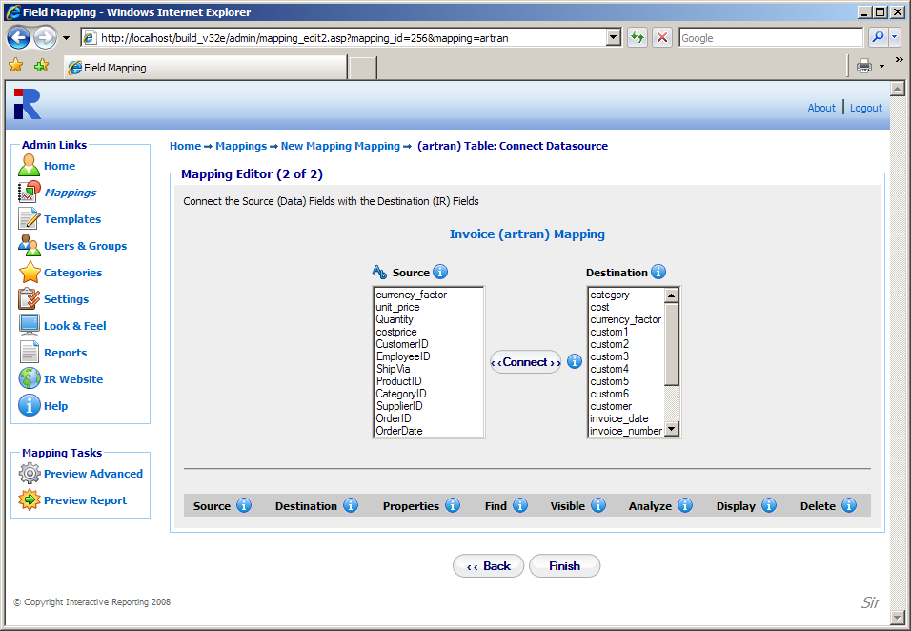
Figure 9

Map Transaction Fields
When creating a new mapping the second page of the mapping editor mainly shows two lists. The source list that includes all the fields from the main transaction table, which have been selected from a global table or from the appropriate SQL statement, as described above. The letter symbol above the source list may order the fields alphabetically or in the order selected from the datasource. The destination list contains all the fields that comprise the Interactive Reporting template that is used with the mapping. The latter can contain numeric elements, such as qty, cost, that can be associated with corresponding numeric fields from the data source that will be used to construct the quantities that appear at the reports. It can include currency quantities to map currency factors. And finally, it can consist of textual elements, called ‘Lookups’ that can be used to map data source fields with child attributes that can also be mapped.
In order to Map a Transaction Field, first the user must highlight the field of interest from the source list, for example ProductId. Then, the user must highlight the template field they want it to be mapped to from the destination list, for example item. When both fields are selected the ‘Connect’ button must be clicked. The mapped field will then appear at the list underneath the source and destination lists. Figure 10 shows the Mapping Editor page after a few data source fields have been mapped. Note that when a destination field is mapped it becomes grey and cannot be used again, where a source field can be mapped to more than one destination fields.

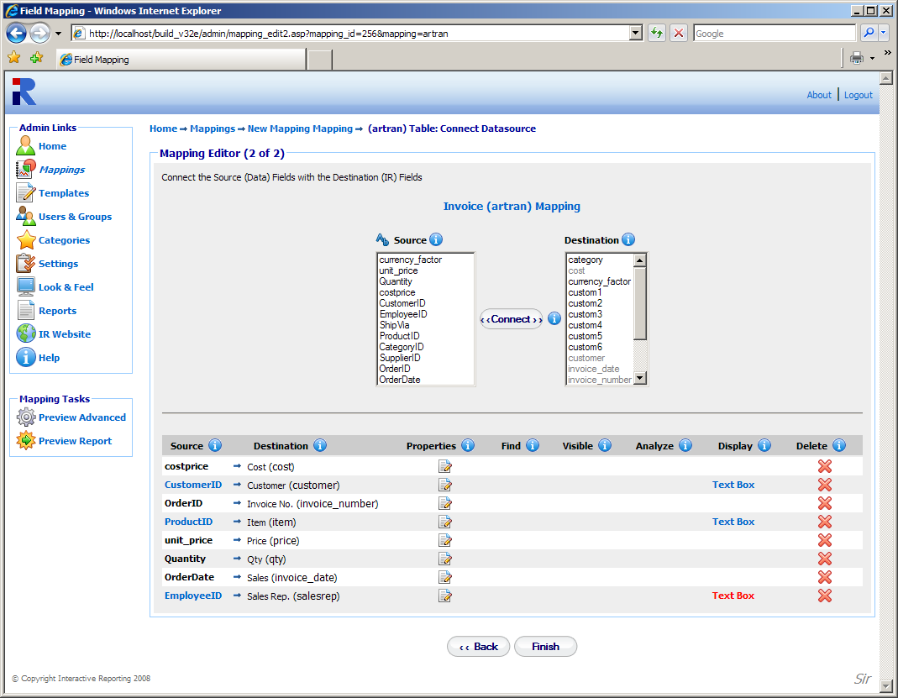
Figure 10

When a source field contains child attributes the user can proceed further to map any of these attributes they wish. Such a source field appears as a link under the ‘Source’ heading, for example ProductId, which could be clicked in order to map further fields from this transaction element. Clicking ProductId directs to the page of Figure 11. The user must then select the table value Products. The filter option for the particular mapped field can also be set, as well as the title of the field. When finished with these selections the user must click the ‘Next’ button, to proceed to the next stage.

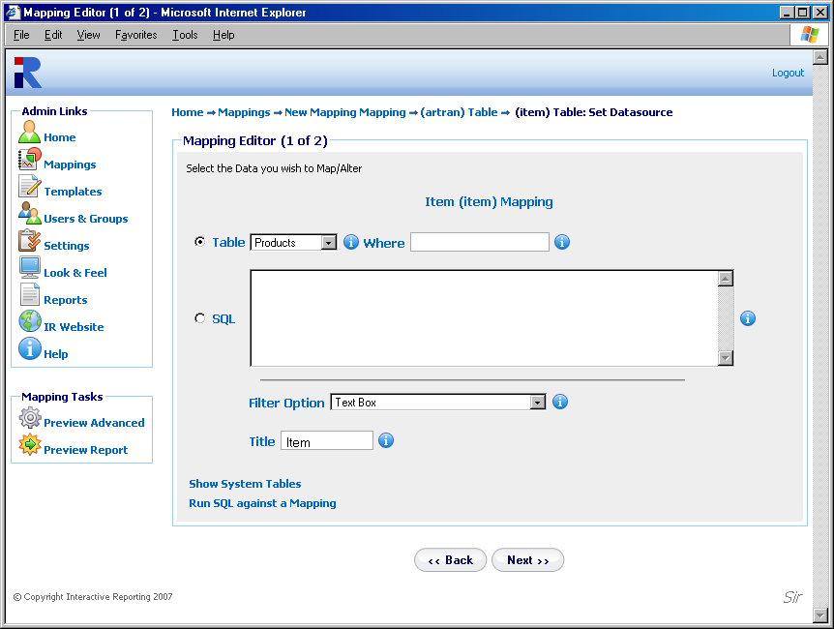
Figure 11

In the example of Figure 10, the data source ProductID field has been mapped to the Interactive Reporting item field. Therefore, any child attributes of ProductId will be mapped to the child attributes of lookup item, as presented in Figure 12, in which the ProductId, ProductName and UnitsInStock source fields from the Products table have been mapped to the item, description and item_custom1 Interactive Reporting item attributes, respectively. In databases it is customary to supply fields with only id/code-numbers, for example ProductId, which are usually mapped to the key attribute of a lookup. However, these id/code-numbers are user-unfriendly, and such mapped fields just exhibit numbers in the reports, thereby preventing the user from easily identifying what they represent. Many databases provide tables to lookup descriptive names corresponding to these id/code-numbers. In such cases the corresponding descriptions may be mapped to the description attribute of the lookup, for example ProductName, to provide clarity to the reports. If the table provides fields with additional information that can be accessed within a report, these can be mapped to additional attributes of the Lookup, for example UnitsInStock.

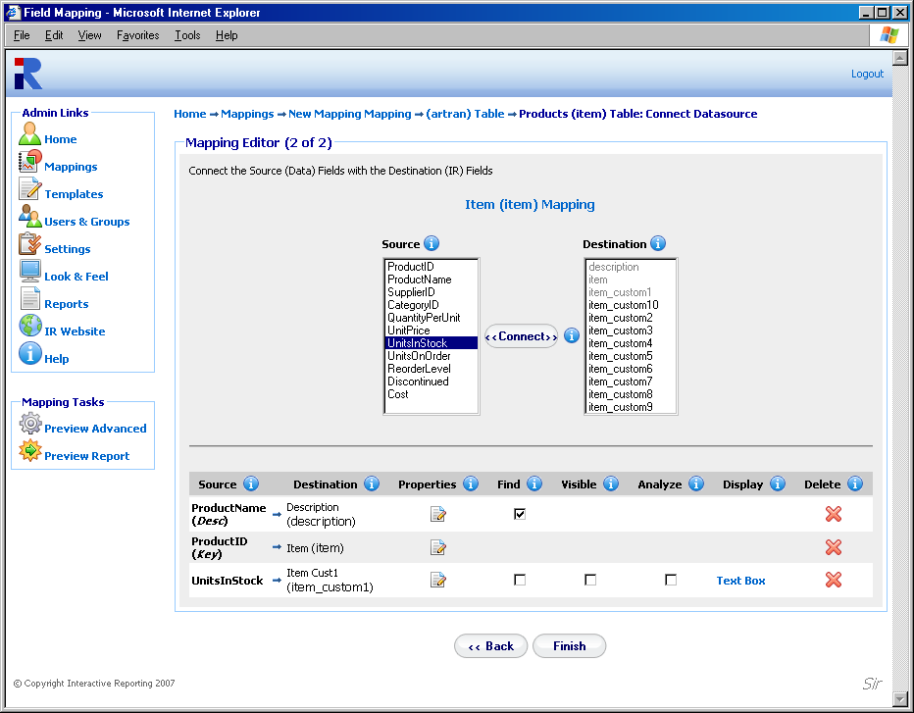
Figure 12

When the user finishes with the mapping of the textual field, the ‘Finish’ button should be clicked. The user is then directed to the Mapping Editor Master Screen, shown in Figure 13. The user can then proceed with any other textual field they wish to configure, either by going to the main transaction page and following the procedure discussed above, or by clicking on the name of the next textual field they wish to map further. When done with all the fields the ‘Save’ button must be clicked, and the user returns to the Mapping List page, Figure 4, with the new mapping included in the list.

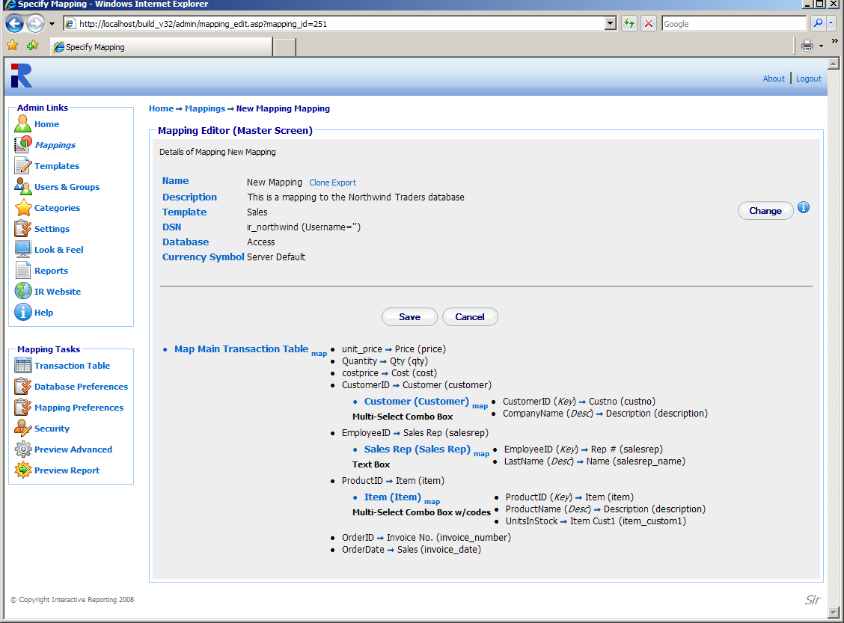
Figure 13

Edit Mapping
When creating a new mapping or editing an existing one, a number of options can be modified, as will be explained in this section. To Edit a Mapping, just click on the Mapping Name in the Mappings Page (Figure 4), to be directed to the Mapping’s Master Editor Screen, similar to Figure 13. The master screen contains three parts that can be edited: the database preferences, the transaction table, the mapping preferences and the security.
To edit the database preferences the user must click either the ‘Change’ button at the first part of the page or the ‘Database Preferences’ option of the ‘Mapping Tasks’ menu. The user then goes to a page as shown in Figure 14, in which they can change any of the data source options presented there.

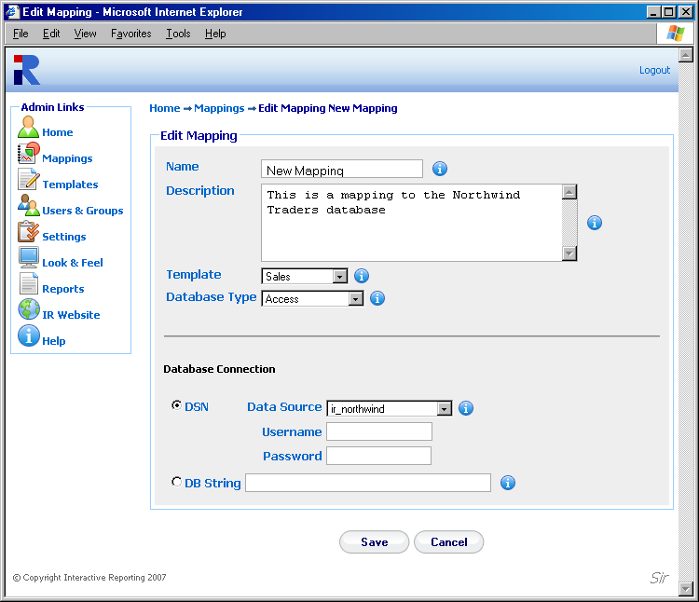
Figure 14

To edit the Transaction Table the user must click the ‘Map Main Transaction Link’ of the second part of the editor page or the ‘Transaction Table’ of the ‘Mapping Tasks’ sidebar menu, to get to the main mapping pages of Figure 8 and Figure 10. If the user wishes to edit any individual mapped elements only, they can click the elements’ name to go to pages such as those in Figure 11 and Figure 12. Alternatively, the user can click the ‘source’ link to get directed immediately to the pages of Figures 10 or 12. In these pages, the user can perform actions in the same way as discussed when creating a new mapping. In addition, there is an extra set of options that the user can set. These are the ‘Properties’, the ‘Find’ option, the ‘Visible’, the ‘Analyze’ and the ‘Display’ option. These are available to change depending on the type of the mapped field, whether numeric or textual, and the type of textual field, whether key, description or attribute.
When clicking the ‘Properties’ icon a new browser window opens, such as the one in Figure 15. In this new window, the user can change the name of the mapped field to how they prefer it to show in reports. If the ‘Filter Required’ box is ticked, this field becomes mandatory to the reports. Thus, every time a report is generated this item MUST have a value selected, otherwise an error will appear. Such fields are indicated on the report page by a *. The ‘Link Url’ property enables the user to link to data external to the report viewed at any instance. The ‘Link Url’ value can be of the form ‘http://filepath?source field=%destination field%’. When a mapped field has such a url provided, when viewing a report based on that field, a blue arrow will appear next to each value of this field. If this blue arrow is clicked, it redirects to the appropriate external page, where information about that specific value can be viewed. Clicking the plus symbol next to the text box, auto completes the url with the relevant value for %destination field%. When the mapped field is numeric, for example qty, the properties window will provide only the option to change the name of the field.

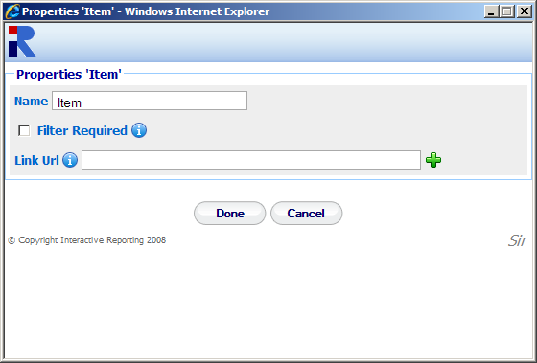
Figure 15

The ‘Find’ option, when checked, results in a search icon (a magnifying glass) being displayed next to the particular field on the filters section of the Interactive Reporting wizard or advanced pages. This allows the user to perform searches on this element.
The ‘Visible’ option, allows a mapped field to appear in the filters section of the Interactive Reporting wizard or advanced pages. Note, however, that this field will not be included in the 'Analyze By' list.
The ‘Analysis’ box, if ticked, allows the user to analyze by this field.
The ‘Display’ option is associated with the format of the mapped field in the filter section of the main reporting page. This can be set by clicking the link value associated with the appropriate field, see Figure 10 and Figure 12, or by selecting a value from the ‘Filter Option’ list of pages like the one in Figure 11. There are nine display types to choose from:
- Combo Box: displays a select list from which only one value can be selected at a time.
- Combo Box w/code: displays a select list from which only one value can be selected at a time. Each value is shown with its associated code.
- Multi-Select Combo Box: displays a select list from which multiple values can be selected. The first value is ‘All’, which means a report will be generated with all values included if this option is selected.
- Multi-Select Combo Box w/code: displays a select list from which multiple values, with their associated codes, can be selected. The first value is ‘All’, which means a report will be generated with all values included if this option is selected.
- Multi-Select Combo Box (w/o All): the same as the ‘Multi-Select Combo Box’ type but without the ‘All’ option.
- Multi-Select Combo Box w/code (w/o All): the same as the ‘Multi-Select Combo Box w/code’ type but without the ‘All’ option.
- Text Box: displays a blank box into which the user may enter their desired value. If the ‘Find box’ is also selected, only the selected data will be displayed in the search box.
- Text Box w/code: displays a blank box into which the user may enter their desired value. If the ‘Find box’ is also selected, when a search is performed, the codes will be displayed along with the search data.
- None: the mapped field does not appear at the filters section. Note that when this type is selected the ‘Filter Required’ and ‘Find’ options are not applicable.
Once the user is satisfied with all the options, they must click ‘Finish’ to save the changes in the system. When the mapping process is completed it is essential to click the ‘Save’ button of the master editor. If this is not done a red exclamation mark will appear next to the mapping name in the mapping list. This indicates that when the user attempts to access the unsaved mapping to generate reports a warning will appear notifying them that the mapping needs to be validated.

Mapping Preferences
In addition to editing the mapping elements, the user can also edit the mapping preferences. These refer to overwriting some of the system settings and/or modifying the Graphical User Interface (GUI) for the particular mapping. To edit the mapping preferences the user must click the ‘Mapping Preferences’ option of the ‘Mapping Tasks’ sidebar menu. The user gets directed to the page of Figure 16. This page contains three parts, the ‘System Preferences’, the ‘Report Configuration’ and ‘Security’. In order to select which one to view, the user must click on the corresponding header titles of Figure 16.
In the ‘System Preferences’ tab, Figure 16, the user can set the currency symbol to be used at the reports, and they can overwrite some of the system settings. To perform the latter, the user must set the ‘Use Default System Values’ option to ‘No’. Then, the remaining options are enabled and the user can select to alter any of them. When the user generates reports based on this mapping the selected system preferences will be utilised, even though other mappings retain the system settings (to be discussed in detail in a following chapter).

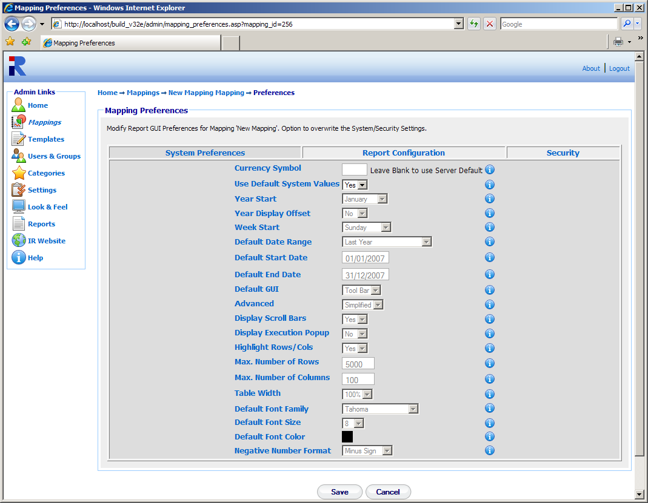
Figure 16

In the ‘Report Configuration’ tab, Figure 17, the user can decide on which features of Interactive Reporting they wish to retain. The ‘Disabled’ list should contain the features that the user doesn’t need and the ‘Enabled’ list should hold the Interactive Reporting features to be used. To move a feature between the lists, the user must highlight the feature of interest, and either double click on it or click any of the appropriate buttons between the two lists As an example, let’s assume that the user doesn’t want to generate reports through the Wizard interface, that they don’t need any filters, and they don’t want to use the paging option. The user must then highlight the Wizard, Filters and Paging options (for multiple selections hold the Ctrl key while highlighting the required values) and click the ‘<’ button. The result of this selection is shown in Figure 18. When running reports these elements of Interactive Reporting will be absent.
When the user finishes with both the system preferences and the report configuration set up they must click the ‘Save’ button to return to the master editor page, where they can save all their changes and finish with the editing of the mapping.

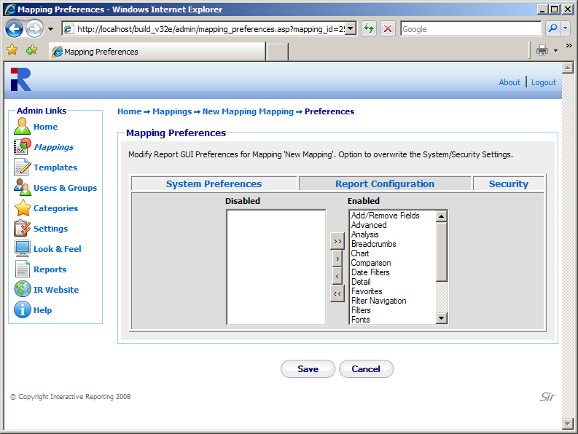
Figure 17

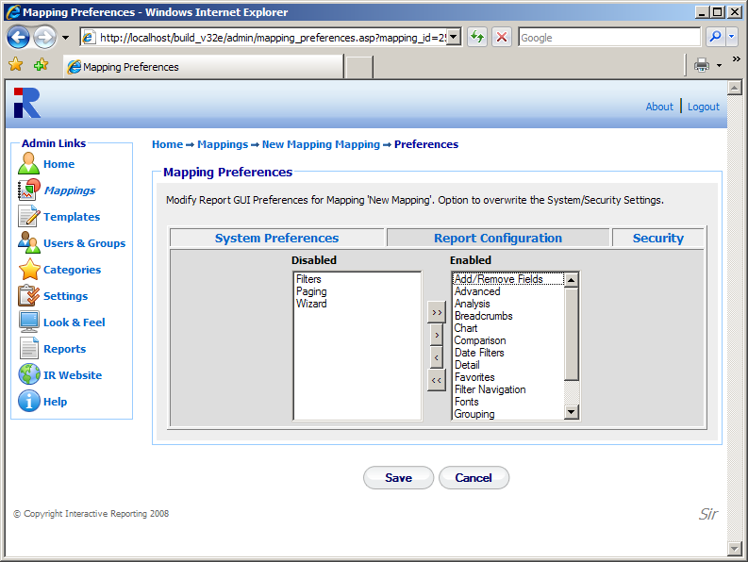
Figure 18
In the ‘Security’ tab, Figure 19, the user can select whether they wish to apply any security settings to the particular mapping when viewing the associated reports. To change the security settings for this mapping only, the user must set the ‘Use Values from Template’ option to ‘No’.

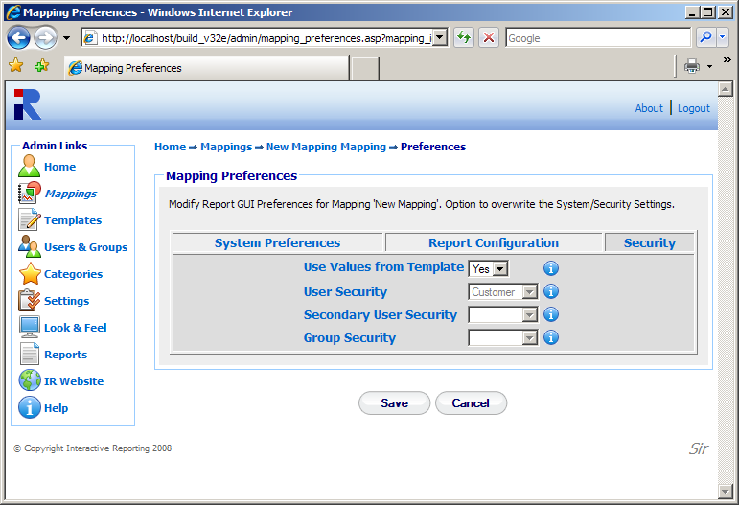
Figure 19

Security
In addition to editing the mapping elements, the user can also view which users have access to the particular mapping and which access level correspond to each user. To edit the security settings the user must click the ‘Security’ option of the ‘Mapping Tasks’ sidebar menu. The user gets directed to the page of Figure 20. The user can then select who should have Full Access, No Access, or Restricted to the relevant template fields for the particular mapping.

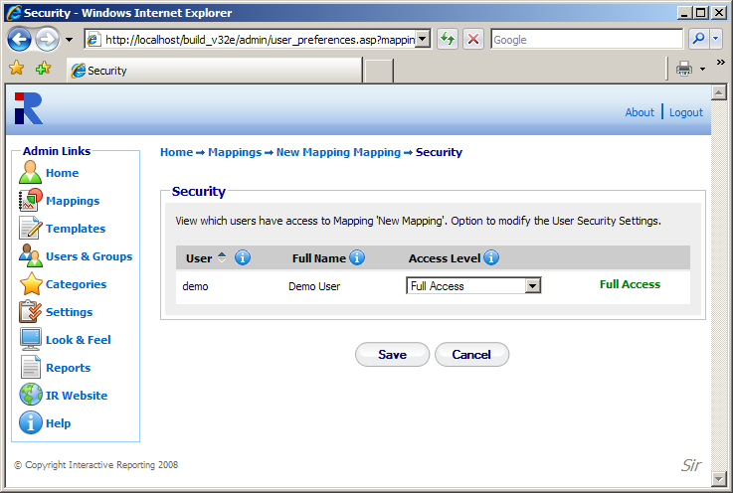
Figure 20

Preview
When a user is editing a mapping from the mapping editor master page, Figure 13, or any of the table editor pages, Figures 11 and 12, they have the option to preview what they have edited directly from the Interactive Reporting side. This can be achieved by clicking the ‘Preview Advanced’ or ‘Preview Report’ options from the ‘Mapping Tasks’ sidebar menu. The ‘Preview Advanced’ option directs the user directly to the ‘Advanced’ report interface associated with the particular mapping, as seen in Figure 21. From that page the user can generate reports based on the mapping that they have created up to this point. If the user wishes to return to the mapping editor page from where the preview option was selected to modify further the mapping, they can click the ‘Edit’ link at the header of the advanced page.

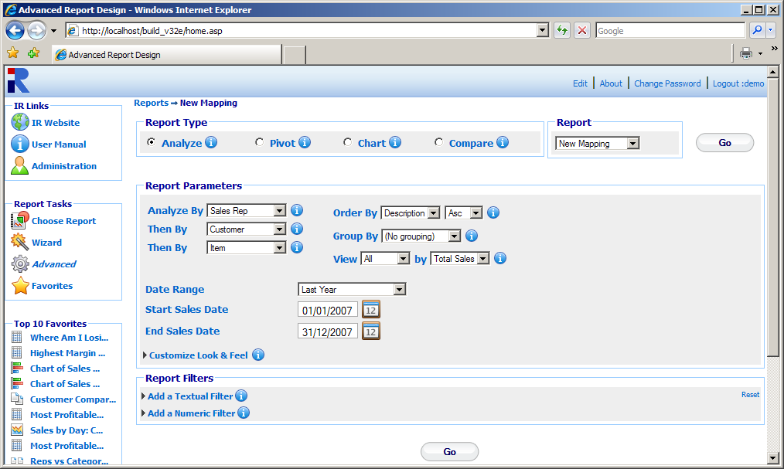
Return to report editing in administration
Figure 21

The ‘Preview Report’ option directs the user directly to the report page generated from the particular mapping, as seen in Figure 22. From that page the user can go on with viewing reports based on the mapping that they have created up to this point. If the user wishes to return to the mapping editor page from where the preview option was selected to modify further the mapping, they can click the ‘Edit’ button at the toolbar section of the report page.
Note that if the user tries to preview a mapping to which they have no access to, an error message will be displayed, recommending the user to first obtain access to the mapping and then try to preview it.

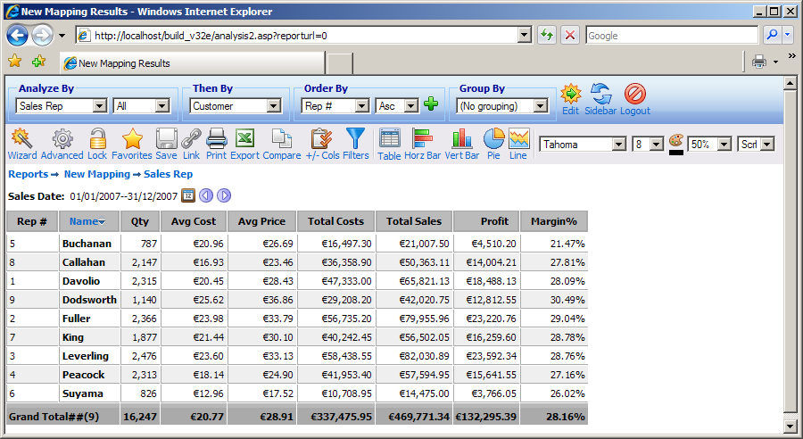
Return to report editing in administration
Figure 22

Template
Chapter
5
How to Create and Operate Templates Easily…
interactive Reporting allows the user to easily modify database criteria, without having to deal with database tables or forms by using Templates. A template must be created for each database that is to be made available to the users.

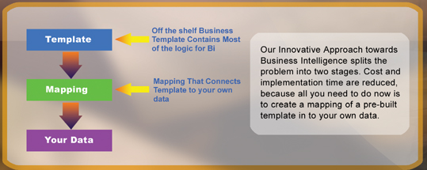
Figure 23

Templates can be Created, Edited, Deleted, Cloned, Imported and/or Exported or just viewed. To access the ‘Templates’ section click on the ‘Templates’ link of either the ‘Administration Options’ menu or of the ‘Admin Links’ sidebar menu at the left of the page of Figure 3. The user will then get directed to a page like the one shown in Figure 24, which contains a list of all available templates.

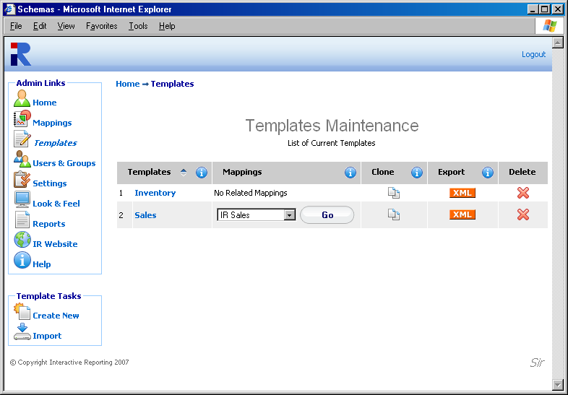
Figure 24

Each template is characterised by a user-friendly name that is shown in the column ‘Templates’. In Figure 24 there are two templates, one called Inventory and one called Sales. Clicking the template’s name link allows viewing the template details and/or editing the template’s options. The ‘Mappings’ column shows all the mappings that have been created based on the particular template. If a template has been used for more than one mapping, these are shown in the form of a select list. To go to a specific mapping related to that particular template, select it from the list and click the ‘Go’ button next to the mapping list. The ‘Clone’ option creates a complete copy of the template. Cloning a template can save time in creating a new one, and reduces the testing time. To clone a template, click the ‘Clone’ icon next to the template of interest. To export a template, click the ‘Export’ button next to it. This will cause a box to pop up on screen prompting the user to save the template to their desired location. To delete a template just click the delete icon relevant to the template that is no longer required.
The ‘Template Tasks’ offer the ability to create a new template and import an existing one.

Import a Template
To import a template click the ‘Import’ link of the ‘Template Tasks’ section on the left side of the templates maintenance page. The user is then directed to the ‘Import Template’ page as can be seen in Figure 25. The user simply enters the path where the stored template is located or uses the ‘Browse’ button to locate the template if unsure of the destination path. When the destination path is provided click the ‘Import’ button to return to the templates page. If the user tries to import a different version of an existing template, they will first get to the ‘Upgrade Template’ page, Figure 26, in which they will be asked to verify whether they really like to upgrade the existing template. Once the template is imported it will appear within the list of available templates.

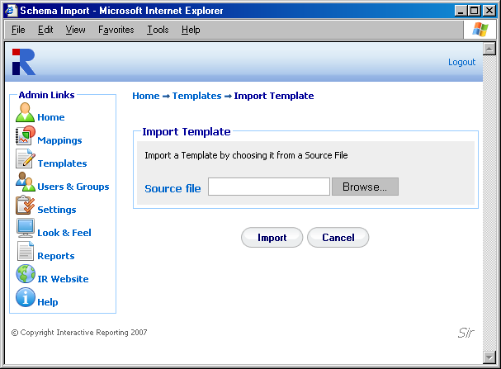
Figure 25

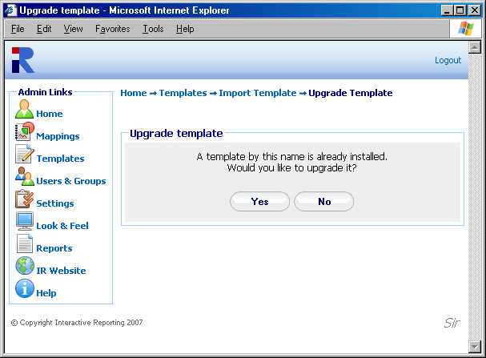
Figure 26

Create New Template
To create a new template, click the ‘Create New’ link of the ‘Template Tasks’ section on the left side of the templates maintenance page. The user is then directed to the ‘Create New Template’ page as can be seen in Figure 27. First complete the name to be used for the new template. Next enter a description of the new template. Provide the name of the ‘Principal Table’. The ‘Principal Table’ contains all the information about ‘Variables’, ‘Calculated Variables’ and ‘Lookups’. When creating a new template the ‘Advanced’ link should not be clicked, as lookups must be added before it provides additional functionality. Once the data has been entered the user must press the ‘Save’ button to continue to the next step in which they can enter variables, calculated variables and lookups, Figure 28.

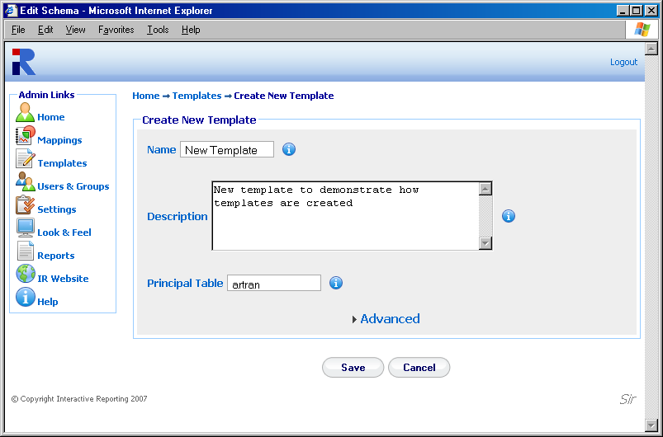
Figure 27

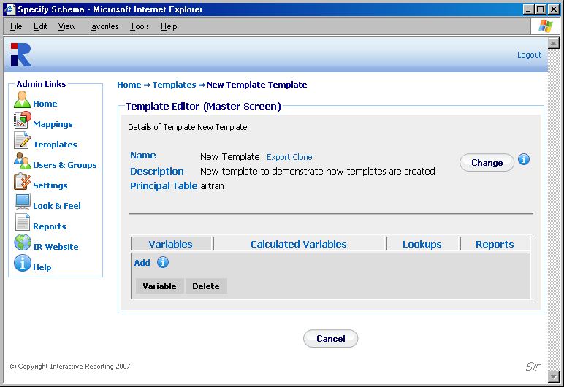
Figure 28

Once the template preferences have been set, the user can add all the variables, calculated variables and lookups to constitute the new template, and can configure the different report types based on this template.

Variables
This list contains numeric or currency quantities that are used for the evaluation of the Calculated Variables. To add a new variable, click the ‘Add’ link of the ‘Variables’ tab to be directed to the ‘Add Variable’ page, Figure 29.
First, the user must give a name to the new variable, for example qty. The ‘Name’ field should not be left blank and it should be unique. Try to make the name of the variable as user friendly and descriptive as possible. This field cannot contain spaces. Valid variable names can begin only with text, and they can contain only text, numbers or the underscore (_). The ‘Type’ option determines whether the variable is going to be numeric or currency. By clicking on the ‘Advanced’ link more options become available. The ‘Default Value’ should be either blank or numeric. The ‘Required’ field determines whether this variable should be mandatory when used in a mapping. If ‘Yes’ is chosen the variable must always be mapped in the principal table. When finished, click the ‘Save’ button to return the template editor master screen.

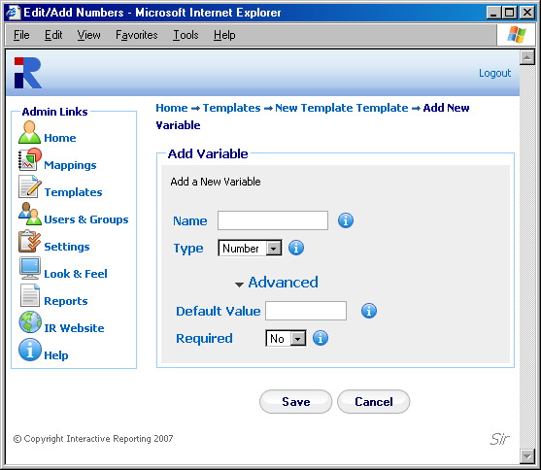
Figure 29

Calculated Variables
The ‘Calculated Variables’ are the numeric quantities that appear in the reports. To add a new calculated variable, first click on the ‘Calculated Variables’ tab of the template editor master screen, Figure 28, and then click the ‘Add’ link to be directed to the ‘Add Calculated Variable’ page, Figure 30.
First, the user must give a title to the new calculated variable, for example Avg Cost. The ‘Title’ field should not be left blank, and it should be unique. Try to make it as user friendly and descriptive as possible. This field cannot contain spaces. Valid titles can begin only with text, and they can contain only text, numbers or the underscore (_). The user must then select the type of the calculated variable, i.e. whether it is going to be a number, a currency, a percentage field or whether it is going to be a date.
The next part of the calculated variable editor determines the expression that evaluates the variable. The user must select the appropriate function, such as ‘Sum’, ‘Min’, ‘Max’, ‘Count’, ‘Weighted Sum’ and ‘Conditional’. The required formula must then be entered in the text box provided. The formula can contain numbers, mathematical expressions, functions of variables or lookups, dates. If the function selected is the ‘Weighted Sum’, the expression will require both a numerator and a denominator and two text boxes will appear. The formula text fields can be filled either by editing directly the text boxes or by choosing a field from the list that appears above them and clicking the ‘Add’ button next to it to insert the selected field automatically into the text box required. The mathematical operators next to field list are used in the expression text boxes. The user can either type them into the text boxes or they can click on any operator to directly insert it at the position of the cursor/caret of the expression text boxes. Care should be taken not to have the denominator equal to 0.
When selecting the function for the calculated variable, there is also the option to set conditions on the report data when displayed. This is performed via the function option ‘Condition’. When choosing this option two text boxes appear, the upper text field will correspond to the condition of interest, and the lower text field will hold the value if this condition is true.

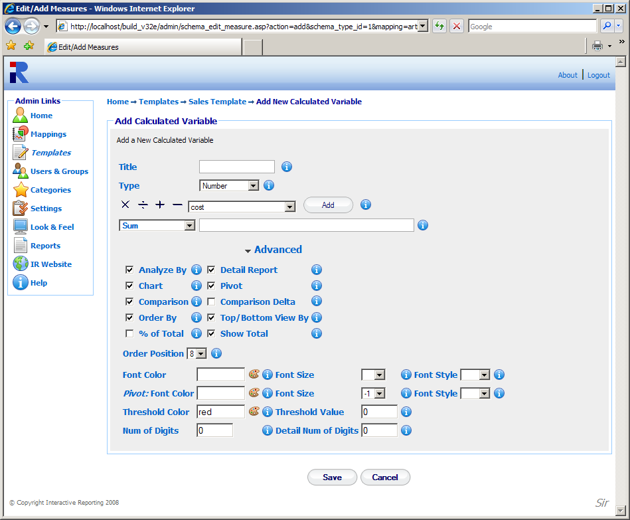
Figure 30

If the user wishes to proceed with a more detailed editing of the calculated variable, they should click the ‘Advanced’ link to reveal more options, as shown in Figure 30. The user can then select to which type of reports, such as Analyze, Detail, Pivot, Chart or Compare, the calculated variable should appear by checking the appropriate options. They can select whether to allow the option to order by this particular calculated variable, or whether it should be contained in the list of fields for which top and bottom results should be viewed by. If the ‘% of Total’ choice is checked, an extra column appears in the report under the calculated variable heading, showing its respective percentage value. If the ‘Show Total’ choice is unchecked the calculated variable will have no total value in the reports. The ‘Order Position’ determines the order that the calculated variable should appear at the report. The optional font options format the calculated variable’s value when appearing in analysis and comparison reports. There are additional font options to format the calculated variable’s value when appearing in a pivot report, when the ‘All’ pivot option is selected. If a ‘Threshold Value’ is provided, any values lower than this threshold will appear with a different colour at the reports to distinguish them as special values. The different colour for this threshold value is determined by the ‘Threshold Colour’ option. A default value of red is selected. The ‘Num of Digits’ option deals with the possibility that customers may require information that contains fractions of items, and thus allows the user to specify the limit of the digits output to the screen. For example, if ‘Num of Digits’ is set to 4, a datum of 6.25 in the Qty field will be displayed as 6.2500. The default values of this option are 2 for type of calculated variable set to currency and for the ‘Weighted Sum’ function, and 0 otherwise. However, the user can put any value of their choice. The ‘Detail Num of Digits’ sets the calculated variable’s decimal number of digits specifically for detail reports.
When finished with all the options for the new calculated variable, the user must click the ‘Save’ button to return to the master template editor screen.

Lookups
The ‘Lookups’ list contains the Interactive Reporting fields that compose the destination list of the mapping editor page. To add a new lookup, first click on the ‘Lookups’ tab of the template editor master screen, Figure 26, and then click the ‘Add’ link to be directed to the ‘Add Lookup’ page, Figure 31.

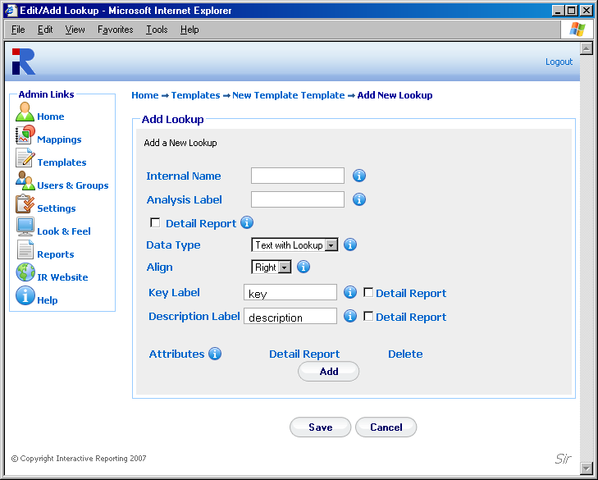
Figure 31

First, the user must give a name to the new lookup, for example item. The ‘Internal Name’ field should not be left blank, and it should be unique. Try to make it as user friendly and descriptive as possible. This field cannot contain spaces. Valid titles can begin only with text, and they can contain only text, numbers or the underscore (_). The ‘Analysis Label’ is used to provide the name that a lookup will have when mapped, and it is the label to be used within the database. This field cannot remain blank. If the ‘Detail Report’ option is checked, the lookup will appear in any Detail Analysis Report.
The ‘Data Type’ field can have one of three values: ‘Date’, ‘Text’ or ‘Text with Lookup’. If ‘Date’ or ‘Text’ is selected the ‘Add Lookup’ page changes to the one shown in Figure 32.

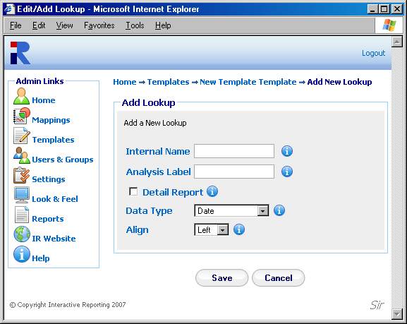
Figure 32

‘Dates’ and ‘Text’ lookups cannot have attributes, whereas the ‘Text with Lookup’ option allows for the determination of child attributes to that lookup, which can be used to map more fields from a textual table of the source database.
The ‘Align’ field determines the side at which the lookup will be displayed at the ‘Advanced’ interface page. The default option is ‘Left’ for ‘Date’ lookups, and ‘Right’ for ‘Text’ and ‘Text with Lookup’.
If the user has selected to add a ‘Text with Lookup’, they must proceed with completing the options for the attributes that will relate to, as shown in Figure 31. The ‘Key Label’ corresponds to the first attribute of the lookup. Its default value is set to ‘key’, but it can be changed to any other name. The ‘Description Label’ is the second attribute of the lookup. Its default value is set to ‘description’, but it can be changed to any other name. Both the key and description attributes can be added to the Detail Analysis report by checking the ‘Detail’ options next to them. Apart form these two default attributes the user can add more custom attributes by clicking the ‘Add’ button under the ‘Attributes’ section.
When finished with all the options for the lookup, the user must click the ‘Save’ button to return to the master template editor screen.

Reports
The ‘Reports’ tab of the master template editor provides a supplementary way to configure the various report types by selecting which fields to appear at each report. This option should be exploited only after the lists of variables, calculated variables and lookups have been completed, so that all the added fields are present to each report type as appropriate. The options available under the ‘Reports’ tab are: ‘Analysis Report’, ‘Detail Report’, ‘Comparison Report’, ‘Comparison Delta’, ‘Chart Report’ and ‘Pivot Report’, as seen in Figure 33. When clicking any of these options the user is then allowed to add or remove fields that they desire to have or not in the selected type of report.

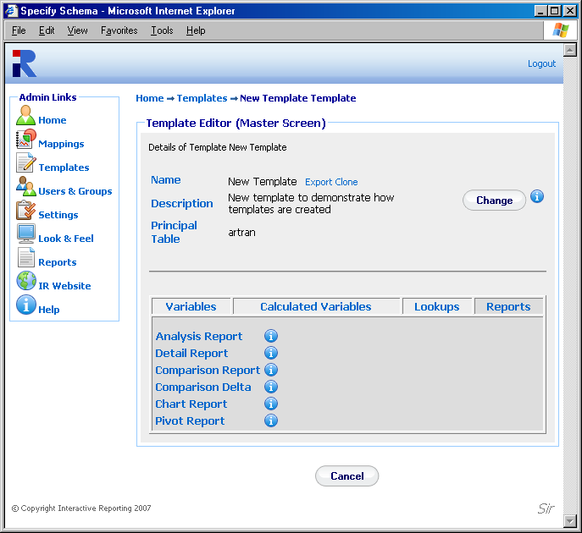
Figure 33

Figure 34 shows how a user can configure an Analysis report. The user has been taken to this page by clicking the ‘Analysis Report’ option of Figure 33. The ‘Choose’ list contains all the fields that can appear at an analysis report. To select which ones should be shown in such a report either highlight the desired fields and click the appropriate buttons to move them to the ‘Analysis’ list or double click on each field of interest. The green arrows allow the user to change the order of the selected fields. Highlighting any selected field and clicking the up or down arrow will move this field up or down by one position. When finished with the selection of fields click the ‘Save’ button to return to the master template editor page. In a similar fashion the user can configure the rest of the options of the ‘Reports’ tab.

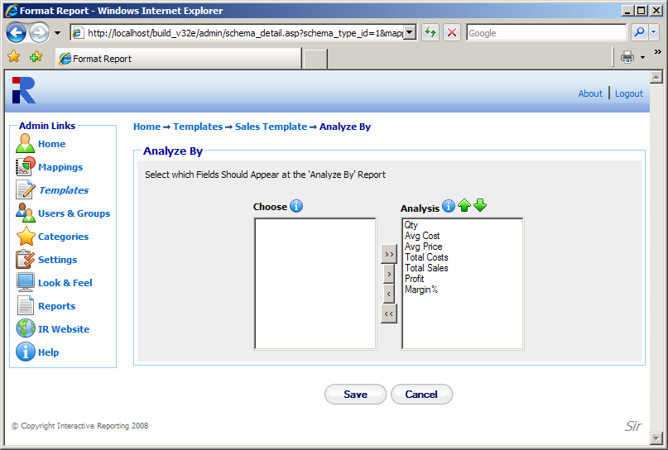
Figure 34

Edit Template
When creating a new template or editing an existing one, a number of options can be modified, as will be explained in this section. To edit a template, just click on the template name in the templates page (Figure 24) to be directed to the template’s master editor screen, shown in Figure 35. The master screen contains five parts that can be edited: the Template Preferences, the Variables, the Calculated Variables the Lookup Lists, and the Reports.
To edit the template preferences the user must click the ‘Change’ button at the first part of the page. The user then goes to a page as shown in Figure 36, in which they can change any of the template options presented there. Clicking the ‘Advanced’ link when editing a template allows the user to edit the default and restricted analyze by options, as well as the user and group security fields. The ‘Num Default DropDowns’ denotes the number of ‘Analyze By’ and ‘Then By’ lists that should appear in the Interactive Reporting Wizard and Advanced Pages. Its value ranges from 1 to 10 such lists. The ‘Default Analyze By 1’ field gives the default field of the ‘Analyze By’ list when the user has been granted full access. The ‘Default Analyze By 2’ to ‘Default Analyze By 10’ field value corresponds to the default value of the subsequent ‘Then By’ lists when the user has been granted full access. The equivalent restricted analyze by values provide the default values when the user has only limited access. The ‘User Security’ field determines at which level data will be displayed in the report. As an example, if ‘User Security’ has been assigned to salesrep and the access level has been set to ‘Restricted to User Key’, as will be discussed at a later section, only the data related to a particular sales representative will be shown at the report. Similarly, the ‘Secondary User Security’ and ‘Group Security’ fields are associated with a secondary and group restriction level, respectively, that can be imposed to the data. Clicking the ‘Save’ button returns the user to the master template editor page.

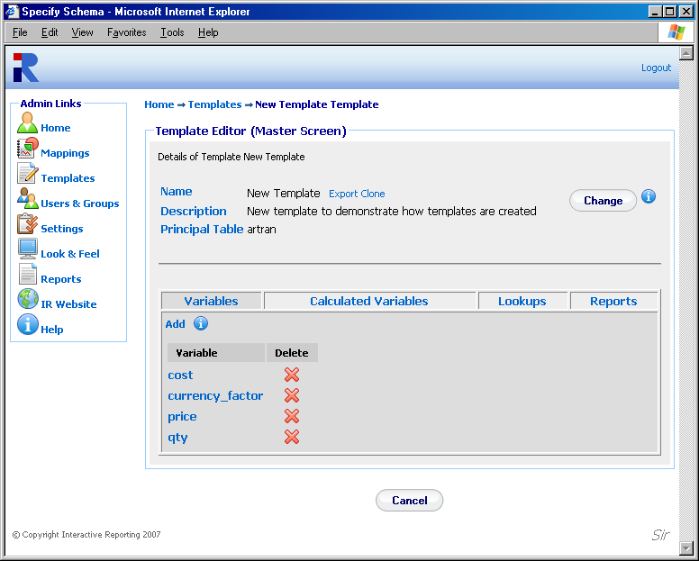
Figure 35
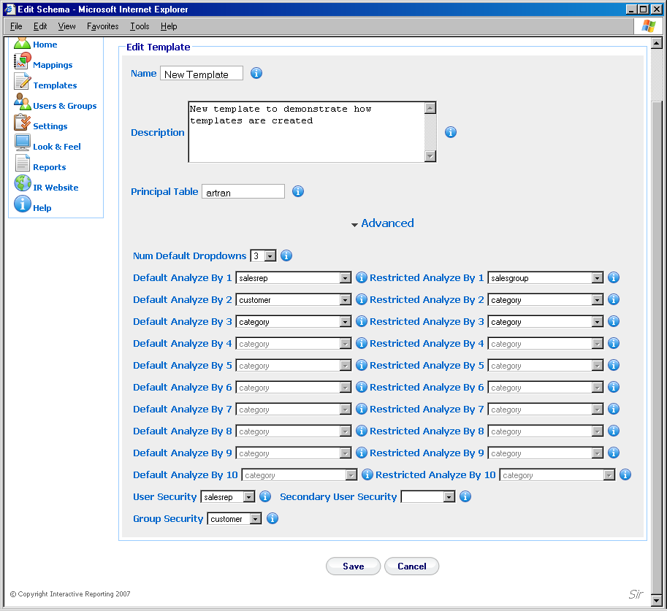
Figure 36

To edit any quantity of the variables, calculated variables, lookups or report lists, first the user must click on the appropriate tab on the master template editor page, and then click on the name of the quantity they want to modify. The user is then directed to a page like the one shown in Figure 29, 30, 31 or 33 respectively, and they can proceed with changing any options they prefer as discussed in the ‘Create Template’ section.

User Management
Chapter
6
Controlling User Access…
Access to Interactive Reporting is managed through User and Group Accounts (much like the accounts that operate at system-level). To access the users section click on the ‘User & Groups’ link of either the ‘Administration Options’ menu or of the ‘Admin Links’ sidebar menu at the left of the page of Figure 3. The user will then get directed to a page like the one shown in Figure 37, which contains a list of all available users and groups.

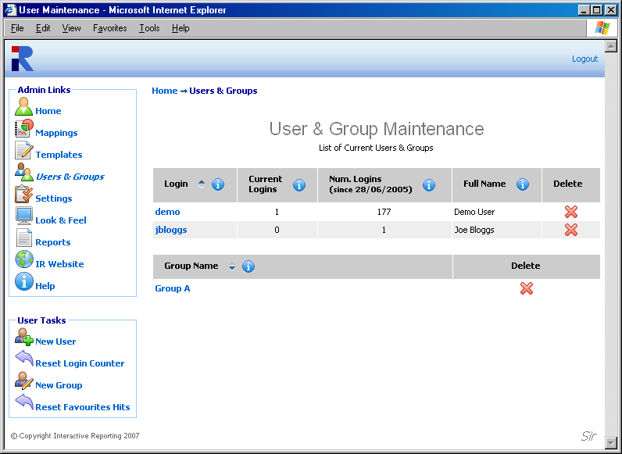

Figure 37
The user and group maintenance page contains two parts: the list of current users and the list of current groups of users. In Figure 37 there are two users, one called demo and one called jbloggs, and there is one group called Group A.
Each user is characterised by a ‘Login’ name that they use to get into Interactive Reporting. Clicking the user’s login name link allows viewing the user’s details and/or editing the user’s options. The ‘Current Logins’ column shows an online record of those users currently logged in to the user side of Interactive Reporting. The record also indicates how many users are currently using a specific account. ‘Num of Logins’ keeps a record of the number of times a user has logged onto Interactive Reporting over a period of time. Clicking the ‘Reset Login Counter’ option at the ‘User Tasks’ sidebar menu resets this number to zero and the count recommences on the current date. The user’s ‘Full Name’ allows the administrator to establish the identity of a user. It may be a person’s name or a description of the account. To remove a user just click the delete icon relevant to the user that is no longer required.
Each group is characterised by a ‘Group Name’ that can be clicked to allow the administrator to establish the identity of a group of users. Clicking the group’s name allows viewing the group’s details and/or editing the group’s options. To remove a group just click the delete icon relevant to the group that is no longer required.
The ‘User Tasks’ offer the ability to create a new user, to create a new group, to reset the login counter, and to reset the number of times users have selected to view favourite reports over a period of time.

Add New User
To add a new user click the ‘New User’ link of the ‘User Tasks’ section on the left side of the users maintenance page to be directed to the ‘Add New User’ page as can be seen in Figure 38. First complete the ‘Login-Name’ that should identify the user. Next provide the password with which the user will be able to login into Interactive Reporting. The ‘Full Name’ should be completed, which could be either the user’s full name or a descriptive name for the account. The ‘Logon Domain’ field restricts the user to the IP address specified. If this field is left blank, the user is allowed access from anywhere in the domain. The ‘Subnet’ option allows the administrator to control the IP address range from which the user can access the site. This can be done from a specific IP address, a range of specific IP addresses or any IP address. There are five different levels to access a site:
- No Restriction – the user can log in from anywhere in the subnet.
- Class A Restriction (255.0.0.0) - If the ‘Logon Domain’ is set to 4.5.6.7 and the ‘Subnet’ is set to 255.0.0.0, the user can log in from machines whose IP address starts with 4. The final three digits in the IP address must be in the range 0-255.
- Class B Restriction (255.255.0.0) - If the ‘Login Domain’ is set to 4.5.6.7 and the ‘Subnet’ is set to 255.255.0.0, the user can log in from machines whose IP address starts with 4.5. The final two digits in the IP address must be in the range 0-255.
- Class C Restriction (255.255.255.0) - If the ‘Login Domain’ is set to 4.5.6.7 and the Subnet is set to 255.255.255.0, the user can only log in from machines whose IP address starts with 4.5.6. The final digit in the IP address must be in the range 0-255.
- Full Restriction or Exact - The user may only log in from machine whose IP address is set to 4.5.6.7.

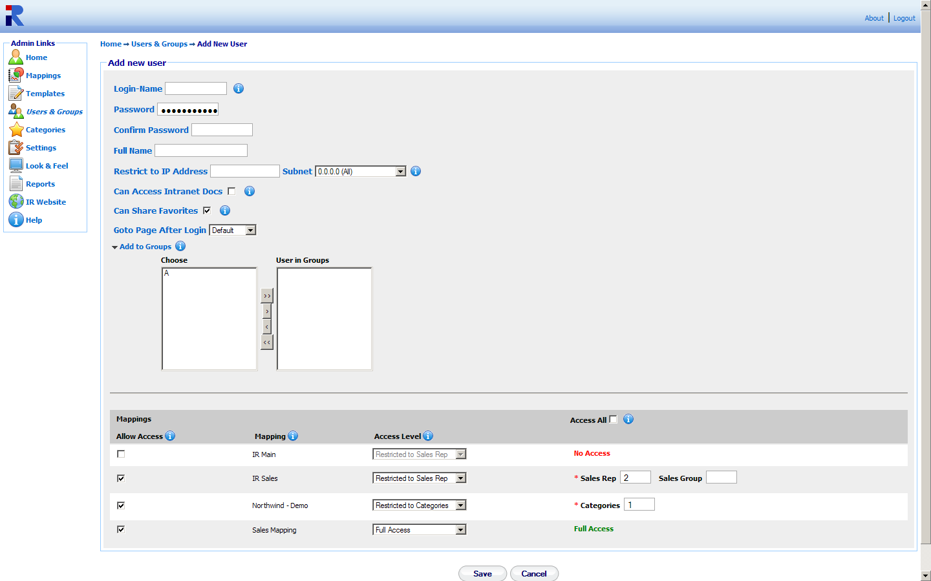
Figure 38

The ‘Can Access Intranet Docs’ option, when selected, allows the user to have access to intranet documents. The ‘Can Share Favorites’ option, when selected, allows the user to share favorites with other users. The ‘Goto Page After Login’ allows the user to select to which page they should get directed upon login in. There are 4 options for this field: ‘Default’, ‘Favorites’, ‘Wizard’, and ‘Advanced’. ‘Default’ directs the user to whichever page is relevant according to the number of mappings they will have access to. ‘Favorites’ directs the user to the ‘Favorites’ page. If the option ‘Wizard’ or ‘Advanced’ is selected the user gets directed to the equivalent page upon login. In this case the user must also select the mapping to which this option should apply. Note, the user must select a mapping to which they have allowed access. If the user is to join any groups, the ‘Add to Groups’ link should be clicked to reveal the option to choose those groups. To select a group either highlight it and click the appropriate button to move it to the ‘User in Groups’ list or double click its name.
The next part of the page sets the access that this new user should have to the mappings that are available at the system. If the ‘Access All’ option is checked the user will be granted full access to all mappings. In this case all the ‘Allow Access’ boxes of the mappings will be automatically checked for the user. Otherwise, the administrator can manually select which mappings should the user have access to, by checking the appropriate ‘Allow Access’ box.
The ‘Access Level’ option indicates the scope the user is permitted for a given mapping. There are four levels of permission the user can be granted: full access, restriction to user key, restricted to secondary user key, restricted to group key.
Full access grants the user full access to the mapping.
The restriction to user key option permits the user to access only data that are associated with the selected ‘User Key’ value. This value is related to the option selected in the ‘User Security’ field in the advanced section of the template editor page, Figure 36. In order to apply such a restriction the relevant field must be mapped, otherwise the option will not appear to the dropdown list. The name of the field as used in the mapping will be displayed in the ‘Access Level’ dropdown list. For example, if the user security field is set to SalesRep and the name of this field in the mapping is Sales Rep, the user will see the option “Restricted to Sales Rep”. When this option is selected two text boxes appear next to it which allow the user to select to which values of the relevant field the restriction will apply. The first text box corresponds to the ‘User Key’ and the second text box corresponds to the ‘Group Key’. The former is compulsory. As an example, if the user has selected “Restriction To Sales Rep” and the value of the ‘Sales Rep’ text box is set to 2, all data displayed for the user will refer ONLY to the Sales Rep whose id is 2. When the user logs into Interactive Reporting they will not see any Sales Rep dropdown option or data in the filter section.
The restriction to secondary user key option permits the user to access only data that are associated with the selected ‘Secondary User Key’ value. This value is related to the option selected in the ‘Secondary User Security’ field in the advanced section of the template editor page, Figure 36. In order to apply such a restriction the relevant field must be mapped, otherwise the option will not appear to the dropdown list. The name of the field as used in the mapping will be displayed in the ‘Access Level’ dropdown list. For example, if the user security field is set to category and the name of this field in the mapping is Categories, the user will see the option “Restricted to Categories”. When this option is selected a text box appears next to it that allows the user to select to which values of the relevant field the restriction will apply. As an example, if the user has selected “Restriction To Categories” and the value of the ‘Categories’ text box is set to 1, all data displayed for the user will refer ONLY to Categories 1. When the user logs into Interactive Reporting they will not see any Categories dropdown option or data in the filter section.
The restriction to group key option permits the user to access only data that are associated with the selected ‘Group Key’ value. This value is related to the option selected in the ‘Group Security’ field in the advanced section of the template editor page, Figure 36. In order to apply such a restriction the relevant field must be mapped, otherwise the option will not appear to the dropdown list. The name of the field as used in the mapping will be displayed in the ‘Access Level’ dropdown list. For example, if the user security field is set to salesgroup and the name of this field in the mapping is Sales Group, the user will see the option “Restricted to Sales Group”. When this option is selected a text box appears next to it that allows the user to select to which values of the relevant field the restriction will apply. As an example, if the user has selected “Restriction To Sales Group” and the value of the ‘Sales Group’ text box is set to 3, all data displayed for the user will refer ONLY to the Sales Group whose id is 3. When the user logs into Interactive Reporting only the data related to that Sales Group would be shown at the report.
When all the options for the new user have been set, click the ‘Save’ Button to return to the user maintenance page, Figure 37.

Add New Group
To add a new group click the ‘New Group’ link of the ‘User Tasks’ section on the left side of the users maintenance page to be directed to the ‘Add New Page’ page as can be seen in Figure 39. First provide the ‘Group Name’ used to identify the new group of users. Next, select which users should be part of this group by selecting their login name and clicking the appropriate button, or by highlighting each login name and double clicking it. When finished with the selection of users click the ‘Save’ button to return to the user maintenance page, Figure 37.
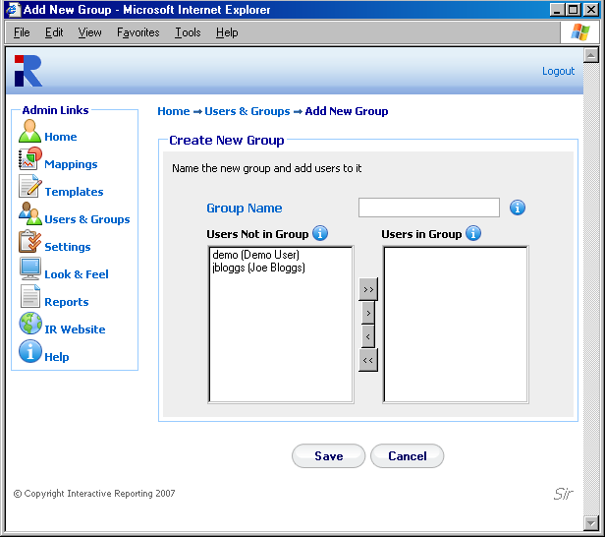
Figure 39

Edit User/Group
To edit an existing user or group click on the login name of the user or on the name of the group to be directed to a page like the one shown in Figure 38 or 39, respectively, and perform changes as described at the previous section.
Categories
Chapter
7
Categorizing Favorite Reports…
Categories contain a list of all categories in which Favorite reports can be grouped. To add a category the user must click the ‘Add’ link as shown in Figure 40. A text box will then appear that will enable the user to provide the new category's name. To add the category the user must click the ‘Save’ icon. To abort any changes, the user should click the ‘Cancel’ icon. To edit an existing category the user must click on the category's name. A text box will then appear that will enable the user to modify the category's name. Clicking the ‘Save’ icon saves the changes to the favorite’s category. To abort any changes, click the ‘Cancel’ icon.

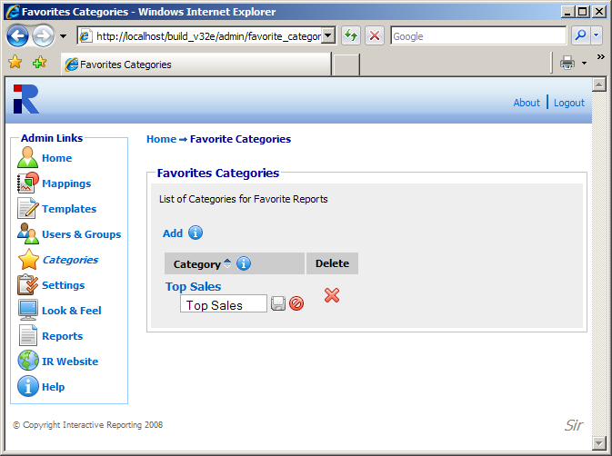
Figure 40
System Settings
Chapter
8
Changing Interactive Reporting Settings…
Anumber of settings with Interactive Reporting facilitate its operation. To access the system settings section click either on the ‘System Settings’ link of the ‘Administration Options’ menu or on the ‘Settings’ link of the ‘Admin Links’ sidebar menu at the left of the page of Figure 3. The user will then get directed to a page like the one shown in Figure 41, which contains all available Interactive Reporting preferences.

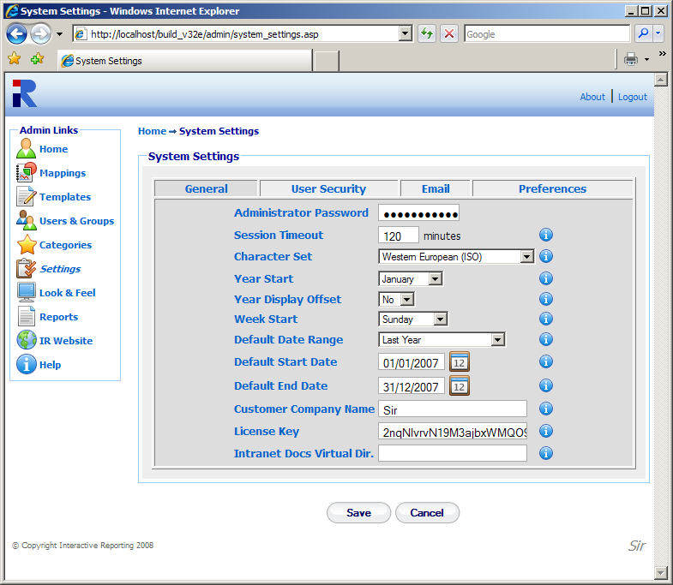
Figure 41

General
To edit any ‘General’ settings the user must click on the ‘General’ tab on the ‘System Settings’ page. The general section contains the following information:
- Administrator Password – the password required to access the administration section of Interactive Reporting (the default password is demo).
- Session Timeout – indicates the time that a user may be idle before being logged out of Interactive Reporting.
- Character Set - determines the character set used in Interactive Reporting.
- Year Start - allows the administrator to set the start date of the financial year. For example, if the accounting financial year starts in July, when the user analyses by year, it will use July-June as the period to measure.
- Year Display Offset - determines the year to display when a date type is used to generate a report, i.e. ‘Analyze by Quarter’. If the ‘Year Display Offset’ is set to ‘Yes’, the year displayed is one greater than the year of the data used to generate the report. This is also tied into the year start value. For example, if ‘Year Display Offset’ is set to ‘No’, a report for ‘Sales by Quarter’ for the year 2003 would be:
Quarter | Qty | Avg Cost
Q1 2003 | €63.03 | €42.19
Q2 2003 | €57.17 | €38.82
Q3 2003 | €62.58 | €37.02
Q4 2003 | €72.17 | €38.64
On the other hand, if ‘Year Display Offset’ were set to ‘Yes’, the above report would be like:
Quarter | Qty | Avg Cost
Q1 2004 | €63.03 | €42.19
Q2 2004 | €57.17 | €38.82
Q3 2004 | €62.58 | €37.02
Q4 2004 | €72.17 | €38.64
Even though 2004 is displayed the data is for year 2003.
- Week Start – sets the day of the week on which the financial week should begin.
- Default Date Range - sets a predefined date range of the wizard and advanced pages
- Default Start Date - sets the default start date of the wizard and advanced pages.
- Default End Date - sets the default end date of the wizard and advanced pages.
- Customer Company Name - required for the licensing of Interactive Reporting. Its value must match that given to Interactive Reporting or to its representative.
- License Key - updates the database with the alphanumeric license key. This unique key will be issued to the user by Interactive Reporting or by the reseller, either for evaluation purposes or on purchase of the product.
- Intranet Docs Virtual Dir. – sets the name of the IIS virtual directory linked to the physical directory of the intranet files.

User Security
To edit any ‘User Security’ settings the user must click on the ‘User Security’ tab on the ‘System Settings’ page, Figure 42. This section contains the following information:
- User Authentication Method – sets the type of user authentication.
- Windows Domain – sets the domain to use for user passwords.
- AD Username to list Users – sets the username required to login to the Active Directory to view the list of users.
- AD Password to list Users – sets the password required to login to the Active Directory to view the list of users
- Password Update Interval - indicates the number of days that a user may use Interactive Reporting before their password expires. If this value is set to 0, password aging does not apply.

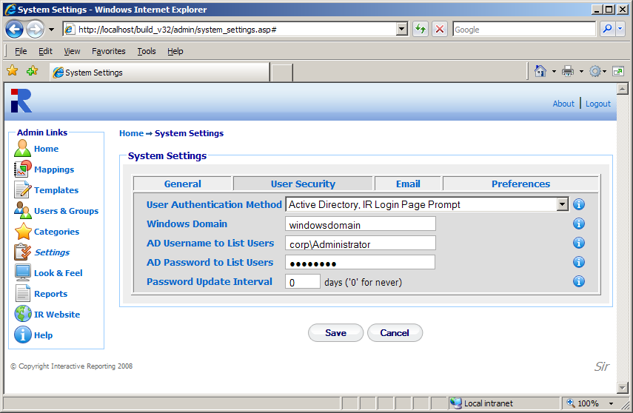
Figure 42

Email
To edit any ‘Email’ settings the user must click on the ‘Email’ tab on the ‘System Settings’ page, Figure 43. This section contains the following information:
- Email Source - the reply-to address of emails when users request reports to be emailed to them.
- Source Name – sets the name from which the email will appear to have been sent.
- SMTP Server – the address of the SMTP server to use for email transfer.
- SMTP Authentication – sets how the emailer gets connected to the SMTP server.
- SMTP User – specifies the username with which the emailer gets connected to the SMTP server if an authentication method is selected.
- SMTP Password – specifies the password with which the emailer gets connected to the SMTP server if an authentication method is selected.
- SMTP Port – specifies the port number, usually port 25, to be used by SMTP on the SMTP Server.
- SMTP Timeout – specifies the timeout with which the emailer gets connected to the SMTP server. This field is optional.
- SSL - specifies whether or not the emailer should use a SSL (Secure Sockets Layer) connection to connect to the SMTP server. Not all SMTP servers support this.
- StartTLS - specifies whether or not the emailer should use a StartTLS (Transport Layer Security) connection to connect to the SMTP server. Not all SMTP servers support this.
- Enable Excel Attachments – permits the emailing of Excel attachments. Excel must have been installed.
- Skip Unicode Formatting – specifies whether or not the emailer should format unicode characters present in emailed reports to a HTML compatible format.
- URL - the HTTP path to the Interactive Reporting web server.

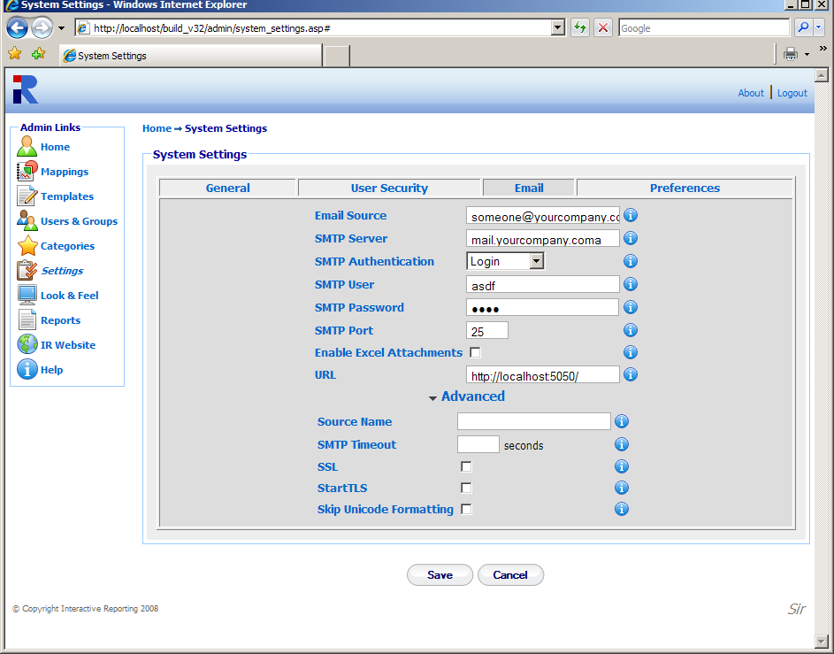
Figure 43

Preferences
To edit any ‘Preferences’ settings the user must click on the ‘Preferences’ tab on the ‘System Settings’ page, Figure 44. This section contains the following information:
- Default GUI – determines the default graphical interface to be used in the report pages.
- Advanced – selects the layout of the ‘Advanced’ interface.
- Display Scroll Bars – activate/deactivate the use of scroll bars in tables when generating reports.
- Display Execution Popup – activate/deactivate an execution popup while a report is being generated.
- Default Comparison Method – determines the default setting of the output of the variation variables in comparison reports.
- Default Ordering Method - indicates the default ordering of reports.
- Filter Value Ordering - indicates the default ordering of data in the filter lists.
- Max Number of Rows – determines the maximum number of rows that can be displayed in a report.
- Max Number of Columns - determines the maximum number of columns that can be displayed in a report.
- Default Font Family – sets the default fonts used in the reports.
- Default Font Size – sets the default font size used in the reports.
- Default Font Color – sets the default font colour used in the reports. A new colour can be selected by clicking the palette icon. The new colour is then shown at the small box next to the palette icon.
- Negative Number Format - determines the format by which negative numbers should be displayed at reports.

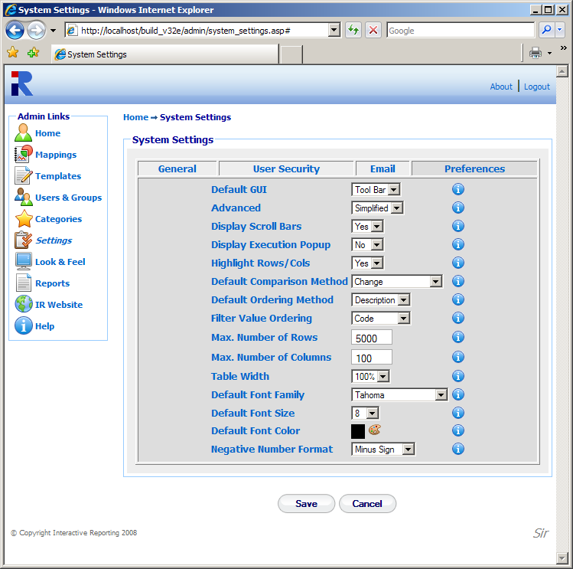
Figure 44

Some of the options of this section can be overwritten on a mapping–specific basis, on the ‘Mapping Preferences’ section. If the user has selected to overwrite the system settings for a mapping, that particular mapping will use the options set by its preferences, whereas all other mappings will use the system settings preferences.
When finished with the setting preferences, click the ‘Save’ button to store the changed settings to the Interactive Reporting system. For some of the changes to appear on the main Interactive Reporting page it may be necessary to shutdown and restart Interactive Reporting.
Look and Feel
Chapter
9
Customize the Look and Feel of Interactive Reporting…
Interactive Reporting offers the option of designing a customised according to the user’s wishes. To access this option click on either the ‘Look & Feel’ link of the ‘Administration Options’ menu or of the ‘Admin Links’ sidebar menu at the left of the page of Figure 3. The user will then get directed to a page like the one shown in Figure 45.
There are two options available to the Administrator for the look and feel of Interactive Reporting. The user can either select the built-in predetermined Interactive Reporting template, or they can select to design their own look and feel by entering their own style sheet. When the latter option is selected the text area under the ‘Design my Own’ option becomes active and the administrator can edit the custom style sheet to match the user’s requirements. A sample style sheet is available for help on how to create a custom design, which can be accessed by clicking the ‘sample.css’ link by the ‘Design my Own’ text area. An example of the sample.css file can be found in Appendix A.
There is also the option to change the header and footer of the Interactive Reporting pages according to the user’s needs or preferences, irrespective of the look and feel template they have chosen. To do this, the administrator must enter into the appropriate text box the style that corresponds to the required header or footer.
To finish with the setting of the look and feel click the ‘Save’ button to store the new options into the Interactive Reporting system.

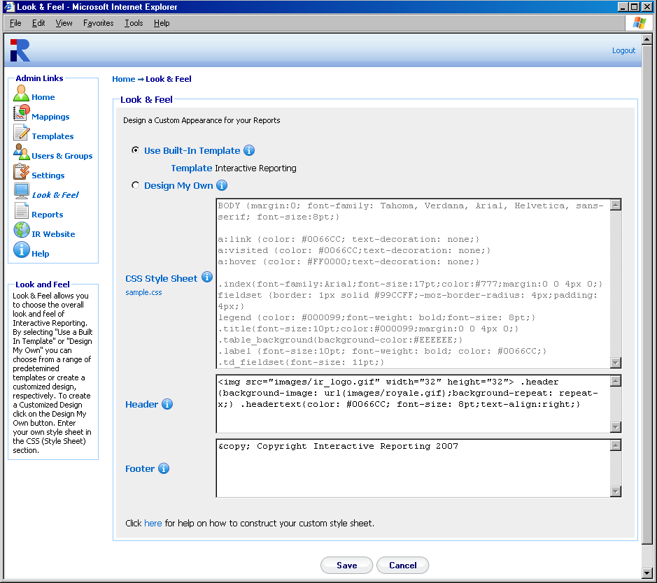
Sample Style Sheet

Figure 45

Interactive Reporting Tools
Chapter
10
Tools for Interactive Development…
Interactive Reporting can be adapted to perform more complex operations for more interactive development. This may be appropriate for more advanced users, so make sure to request your System Administrator’s help if required.

SQL vs Mapping
This utility allows the user/administrator to connect to any of the existing mappings and run arbitrary SQL commands against this mapping. To access this option click either on the ‘Run SQL Commands against a Mapping’ link of the ‘Administration Options’ menu or on the ‘SQL vs Mapping’ link of the of the ‘Tools’ sidebar menu at the left of the page of Figure 3. The user/administrator will then get directed to a page like the one shown in Figure 46. To perform an SQL request, first select the mapping of interest from the ‘Report’ list. Next type the desired SQL statement into the ‘SQL’ text area, and click the ‘Execute’ button. The result set will then be displayed in the page. For example, Figure 47 shows the outcome of running the SQL statement ‘select * from products where categoryid=7’ from the Northwind – Demo mapping.

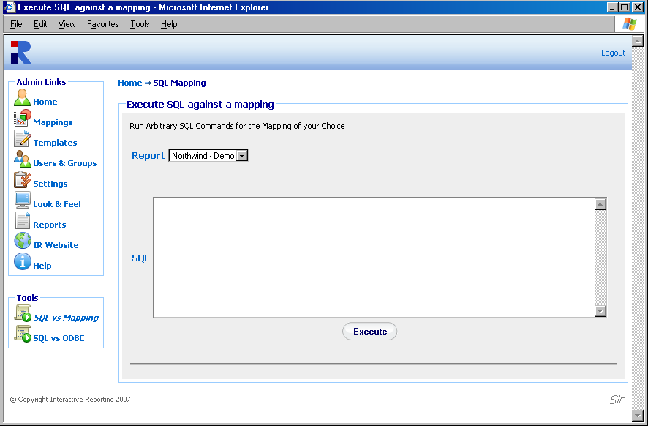
Figure 46
.
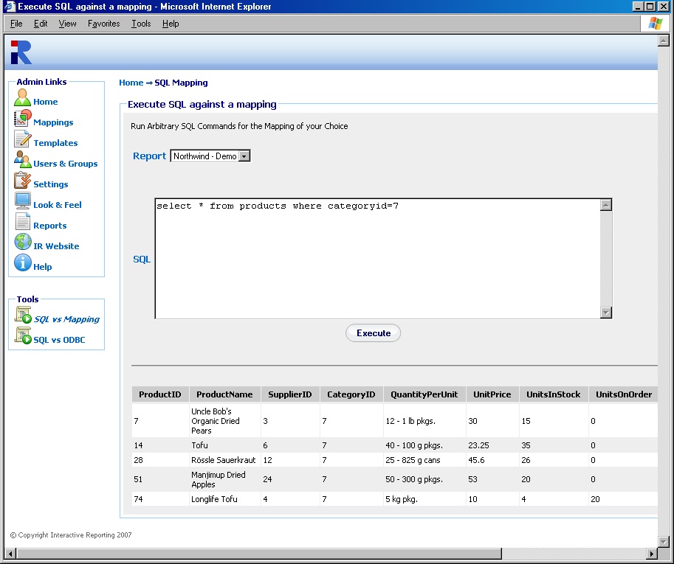
Figure 47

SQL vs ODBC
This utility allows the user/administrator to connect to any of the existing ODBC sources and run arbitrary SQL commands against this connection. To access this option click either on the ‘Run SQL Commands against an ODBC Source’ link of the ‘Administration Options’ menu or on the ‘SQL vs ODBC’ link of the of the ‘Tools’ sidebar menu at the left of the page of Figure 3. The user/administrator will then get directed to a page like the one shown in Figure 48. To perform an SQL request choose the database connection either by specifying a DSN connection, with the appropriate username and password if applicable, or my providing the relevant DB string. Type the desired SQL statement into the ‘SQL’ text area, and click the ‘Execute’ button. The result set will then be displayed in the page, in a similar fashion to running an SQL statement against a mapping.

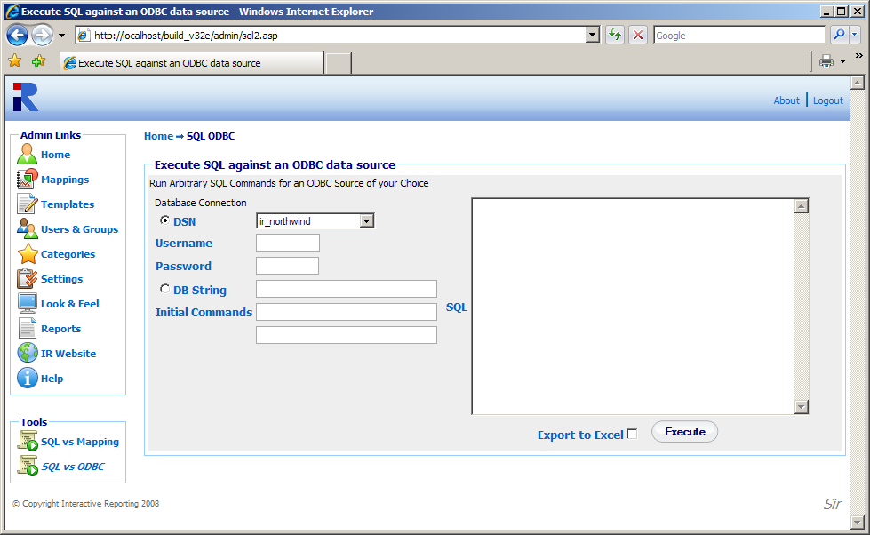
Figure 48

Datapump
This utility allows the user/administrator to transfer data form one ODBC source to another. To access this option click either on the ‘Datapump Tool’ link of the ‘Administration Options’ menu or on the ‘Datapump’ link of the of the ‘Tools’ sidebar menu at the left of the page of Figure 3. The user/administrator will then get directed to a page like the one shown in Figure 49.

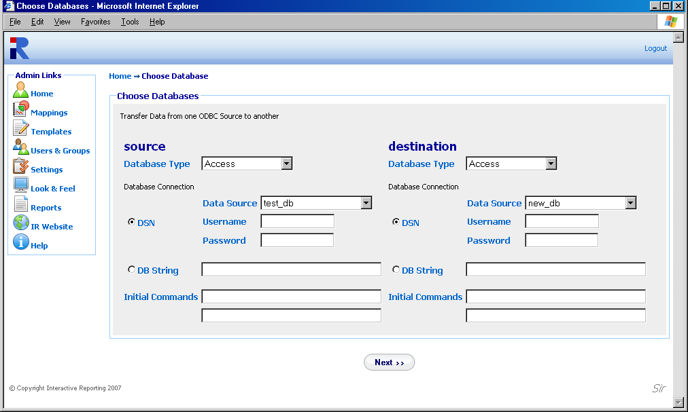
Figure 49

To perform data transfer the user/administrator must first select the database type and database connection details for both the source and the destination databases. Clicking the ‘Next’ button directs to the next stage of data transfer, Figure 50. The user/administrator then selects the tables and fields from these tables that they would like to be transferred to the new data source, and they click the ‘Transfer’ button. When the selected transfer is finished the user/administrator is shown a complete account of the transfer process and is asked whether to perform a new transfer or to return to the administration, Figure 51.

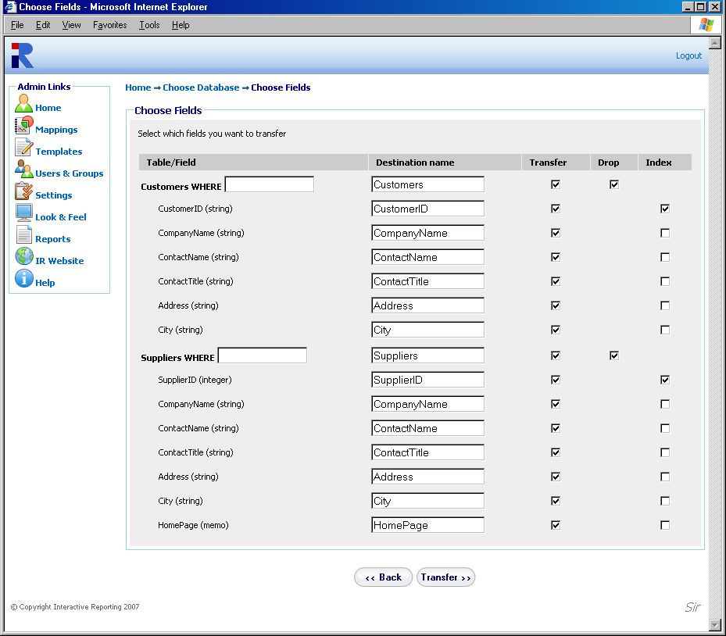
Figure 50

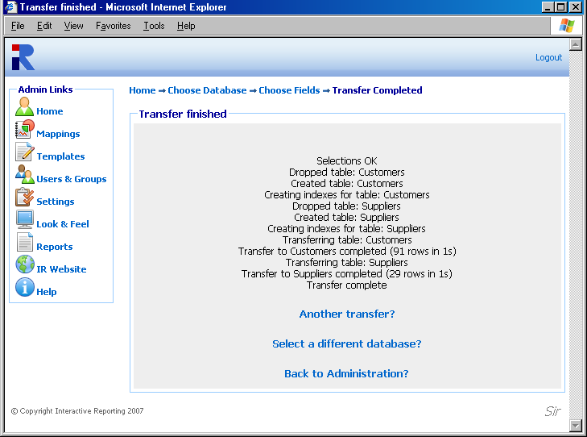
Figure 51
Installation & Removal of IR Service
Chapter
11
Choosing the correct version of Interactive Reporting for you…
There are currently two versions of Interactive Reporting available to a customer: a Standalone Version and a Service Version.

Standalone Interactive Reporting
This version is easily set up. Simply follow the online instructions. To remove Interactive Reporting, go to the control panel. Click on ‘Add or Remove Programs’. Scroll down until ‘Interactive Reporting’ is found and click on this. Once this has been highlighted a ‘Change’ and ‘Remove’ button appear. Simply click on the ‘Remove’ button to remove Interactive Reporting from the system.

Service Interactive Reporting
Services applications can only run on Windows NT, Windows 2000 and Windows XP. To install, save the ir_service.exe executable to a directory with full permissions. For the basic installation type ir_service –i from the command line.

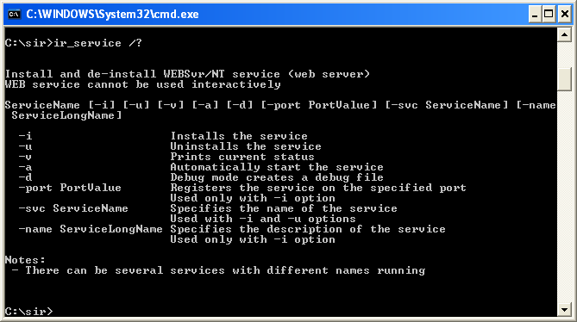
Figure 52

INTERACTIVEREPORTING should now appear in the ‘Services’ section of ‘Settings ->Control Panel -> Administrative Tools -> Services’. Highlight this and click the ‘Start’ option in the top left hand corner. Interactive Reporting should be now ready for use.
To remove the service version, stop INTERACTIVEREPORTING in ‘Settings ->Control Panel -> Administrative Tools -> Services’. Next simply type ir_service –u. Service INTERACTIVEREPORTING removed appears as a confirmation.
Please note that if the extra options available are used in the installation, the exact same syntax MUST be used during removal. E.g. If ir_service –i –svc v30 is used during installation, ir_service –u –svc v30 must be used during removal.

Sample.css
Appendix
A
Sample Style Sheet for Look and Feel Section…
<PRE>
BODY {margin:0; font-family: Tahoma, Verdana, Arial, Helvetica, sans-serif; font-size:8pt;}

a:link {color: #0066CC; text-decoration: none;}
a:visited {color: #0066CC;text-decoration: none;}
a:hover {color: #FF0000;text-decoration: none;}

.index{font-family:Arial;font-size:17pt;color:#777;margin:0 0 4px 0;}
fieldset {border: 1px solid #99CCFF;-moz-border-radius: 4px;padding: 4px;}
legend {color: #000099;font-weight: bold;font-size: 8pt;}
.title{font-size:10pt;color:#000099;margin:0 0 4px 0;}
.table_background{background-color:#EEEEEE;}
.label {font-size:10pt; font-weight: bold; color: #0066CC;}
.td_fieldset{font-size: 11pt;}
.td_descr{font-size: 9pt;}
.description {font-size:8pt;}
.description A {color:#0066CC; font-weight: bold; font-size:9pt;}
.smallLink{font-size:8pt;color:#0066CC;}
.td_sidebar{font-size: 8pt;font-weight: bold;}

.toolbar{background-color:#EBE9ED;}
.buttonText{color: #0066CC; font-size: 8pt;text-align:center;}
.breadcrumb {font-size:8pt;color:#000099;margin:0 0 10px 0;font-weight: bold;}

.reportInfo{font-size: 8pt;font-weight:bold;}
.displayText{font-size: 8pt;text-align:left;}

.errorMessage {font-size: 11pt; font-weight: bold; font-family: arial; color:red}
.promptMessage {font-size:8pt;color:#7F7F7F;margin:0 0 20px 0; }
.noRecordsFound {font-size: 14pt; font-weight: bold; color:red; text-align: center}
.helpPopupBody {font-size:10pt; color: black}

.inputtext {border:1px solid;border-color: #AAA;padding-top:3px;padding-left: 4pt}
.checkbox {font-size:8pt;}
.radio {font-size:8pt;}
.select {font-size: 9pt;}
.selectToolbar {font-size: 8pt;}
.largebutton{width:76px;height:25px;border:medium none;background-color: #FFFFFF;background-image:url('images/button2.gif');background-repeat: no-repeat; font-size:9pt; color:#000066;font-weight: bold;}

.dropmenudiv{position:absolute;top: 0;border: 1px solid #BBB; /*Theme Change here*/width: 200px;color:#0066CC;
border-bottom-width: 0;font:8pt;line-height:18px;z-index:200;background-color: white;visibility: hidden;}
.dropmenudiv a{width: 100%;display: block;text-indent: 3px;border-bottom: 1px solid #BBB; /*Theme Change here*/
padding: 2px 0;text-decoration: none;font-weight: bold;color:color:#0066CC;
filter: progid:DXImageTransform.Microsoft.Shadow(color=#CACACA,direction=135,strength=4); /*Add Shadow in IE. Remove if desired*/}
.dropmenudiv a:hover{ /*Theme Change here*/background-color: #F0F0F0;text-decoration: none;}

.copyright{font-size:7pt;color:#666;}
.customer_company_name {font-size:12pt; font-style: italic; color: gray}
</PRE>.

A Style Sheet is a file that contains style information for elements and is used to enhance the presentation of your web page. The style sheet contains information such as the fonts, colours, borders, and size of elements. To update Interactive Reporting with your style changes simply copy the data from an existing .css file into the text area. A style sheet file ends with the extension .css, e.g. MyStyleSheet.css.
The following data is taken from the current default style sheet available with Interactive Reporting. Altering fields in this file and updating the CSS field with these changes will alter the appearance of Interactive Reporting. Please note that you may have to refresh the browser to view these changes. Please remember to keep the data within the curly {} brackets.
This sets the font options and margin for the background.
BODY {margin:0; font-family: Tahoma, Verdana, Arial, Helvetica, sans-serif; font-size:8pt;}

This sets the colour of unclicked names on links and removes the underlying from the links. e.g. the "Logout" link on the header of Interactive Reporting.
a:link {color: #0066CC; text-decoration: none;}

This sets the colour of clicked names on links. e.g. the "Logout" link of Interactive Reporting turn to #0066CC after being pressed.
a:visited {color: #0066CC;text-decoration: none;}

This sets the colour of links when moving the mouse over a link. E.g. the ‘Logout’ link of Interactive Reporting turn to #FF0000 when hovering over it.
a:hover {color: #FF0000;text-decoration: none;}

The following class deals with the fonts and margin of the general title of a page. E.g., format the title ‘Favourites’.
.index{font-family:Arial;font-size:17pt;color:#777;margin:0 0 4px 0;}

The next set of classes determines the style of the main report Wizard and Advanced pages. They set the fonts and colours of the page title, the background colour, and the style of the descriptions of the fieldsets.
fieldset {border: 1px solid #99CCFF;-moz-border-radius: 4px;padding: 4px;}
legend {color: #000099;font-weight: bold;font-size: 8pt;}
.title{font-size:10pt;color:#000099;margin:0 0 4px 0;}
.table_background{background-color:#EEEEEE;}
.label {font-size:10pt; font-weight: bold; color: #0066CC;}
.description {font-size:8pt;}
.description A {color:#0066CC; font-weight: bold; font-size:9pt;}
.td_fieldset{font-size: 11pt;}
.td_descr{font-size: 9pt;}
.smallLink{font-size:8pt;color:#0066CC;}

The next class sets the font size and style of the links at the sidebar menus of each page. E.g. the sidebar link ‘Wizard’ appears bold.
.td_sidebar{font-size: 8pt;font-weight: bold;}

The following sections set the style of the buttons in the toolbar option on the report page.
.toolbar{background-color:#EBE9ED;}
.buttonText{color: #0066CC; font-size: 8pt;text-align:center;}

The next class formats the style of the breadcrumbs on the top of the report pages that redirect to previously visited pages.
.breadcrumb {font-size:8pt;color:#000099;margin:0 0 10px 0;font-weight: bold;}

This section generates the style of the filter information shown at the report pages when drilling down at a report link.
.reportInfo{font-size: 8pt;font-weight:bold;}
.displayText{font-size: 8pt;text-align:left;}

The following commands change the style of the various error messages.
.errorMessage {font-size: 11pt; font-weight: bold; font-family: arial; color:red}
.promptMessage {font-size:8pt;color:#7F7F7F;margin:0 0 20px 0;}
.noRecordsFound {font-size: 14pt; font-weight: bold; color:red; text-align: center}
.helpPopupBody {font-size:10pt; color: black}

The next set of classes format the various form elements, such as input boxes, select lists and buttons, that appear at various pages of Interactive Reporting.
.inputtext {border:1px solid;border-color: #AAA;padding-top:3px;padding-left: 4pt}
.checkbox {font-size:8pt;}
.radio {font-size:8pt;}
.select {font-size: 9pt;}
.selectToolbar {font-size: 8pt;}
.largebutton{width:76px;height:25px;border:medium none;background-color: #FFFFFF;background-image:url('images/button2.gif');background-repeat: no-repeat; font-size:9pt; color:#000066;font-weight: bold;}

The next class generates the style of the list that appears at the Tool Bar option when there are custom menus set up by the user.
.dropmenudiv{position:absolute;top: 0;border: 1px solid #BBB; /*Theme Change here*/width: 200px;color:#0066CC;border-bottom-width: 0;font:8pt;line-height:18px;z-index:200;background-color: white;visibility: hidden;}
.dropmenudiv a{width: 100%;display: block;text-indent: 3px;border-bottom: 1px solid #BBB; /*Theme Change here*/padding: 2px 0;text-decoration: none;font-weight: bold;color:color:#0066CC;filter: progid:DXImageTransform.Microsoft.Shadow(color=#CACACA,direction=135,strength=4); /*Add Shadow in IE. Remove if desired*/}
.dropmenudiv a:hover{ /*Theme Change here*/background-color: #F0F0F0;text-decoration: none;}

The last section provides the style of the copyright message and Company Name information that appears at the bottom of Interactive Reporting pages.
.copyright{font-size:7pt;color:#666;}
.customer_company_name {font-size:12pt; font-style: italic; color: gray}
Performance Optimisation
Appendix
B
Supercharging Interactive Reporting…
I
f Interactive Reporting is working too slowly, the following should be considered:

- Using Database Indexes
To get reasonable speed it is advisable to create database indexes in the invoice transaction table on the invoice_date, category, salesrep, invoice_number, item and customer fields. Unless this is done, it will be difficult to obtain quick results from the reports.

- Minimizing the number of fields to transfer.
Every field transferred takes up space. Invoice Transaction tables can sometimes have up to 60 fields or more. Interactive Reporting only uses a few of these fields (i.e. item, cost, price, qty, category, salesrep, invoice_date, invoice_number, customer). If only the necessary fields are transferred, and hence the amount of data imported is reduced, then the database access will be quicker. This is particularly true if there are millions of records present. Essentially, the database server does not have to read in or cache as much information. Similarly, if the user has remote locations, where branch or other company data is be stored, it would mean that they would have less data to transfer.

- Separate Database for Analysis.
If a large number of analyses are run, the performance of the accounting system may be affected. One approach to rectify this is to transfer the data to a separate database. We suggest a daily import script to import the data. If this approach is adopted, the real-time reporting capabilities will be lost. Advice on setting-up a separate data warehouse is given in the next appendix. If one of the reports is particularly slow, while most others are fast, it is probable that a database index is missing from one of the columns specified for analysis.

Setting-up a Data Warehouse
Appendix
C
Moving Data About…

If a separate data warehouse is set up, the following tips might be useful:

- Microsoft Access
We recommend that the user keep a template database. Every night, a fresh copy of the template should be made and data should be imported into this new copy. This is a throwaway copy and will be replaced the next night. The reason we recommend this is that file-size grows with every data import and the database will cease functioning once file-size reaches 2GB. The data-warehouse will use the copy.

- SQL Server
We recommend the use of Microsoft Data Import Tool (DTS) to set-up a database task to import the relevant tables. This task can be scheduled either nightly (for the current database) or monthly (for any history file that may exist). We also recommend that transaction logs not be kept on the data warehouse (uncheck ‘Truncate Log’ on the ‘Checkpoint’ option). Otherwise, the database will keep on growing unnecessarily and become unresponsive.

3. History Files
The user should only need to import the history file once a month, while the current file should be imported daily. The reason is that the history file shouldn’t change once the month’s data has been closed. Both History and Current files should be indexed.
If the accounting system does store them separately, they will need to be combined at some stage. The user can combine them by using a View with a union in it. This may be accomplished using the SQL option in the Data-Mapper. The advantage of a union is that it will remove duplicate rows. However, a history signifier should not be included in the union. A combined table can also be generated, though this must be performed carefully to avoid duplicate rows. The current table can contain rows that come from before the start of the period.

- Left Joins
For data consistency, the system is designed to always use a left join whenever data is joined with another table (we do not want the system to lose any rows when trying to calculate a sales figure). If SQL is used, an attempt should be made to try to use LEFT JOINs when combining other tables with the main invoice transaction table from the system. If analyse is performed by several variables with the same filter, and different results obtained, it may mean that the LEFT JOINs are incorrect.
Analysing Other Types of Information
Appendix
D
Extending Interactive Reporting…

Although Interactive Reporting is principally designed to allow analysis of the Accounts Receivable paradigm, it may be extended to the following:

- Sales Order Transactions
Interactive Reporting can be used to analyse sales transactions. The user just needs to connect it to the Sales Transaction database, renaming the column titles.

- Invoices
Even if the user does not have Invoice Transactions available, the invoices can still be analysed. The user should map the invoice line-total to price, and leave quantity unmapped (qty will default to 1). There will be no average cost or average price columns. Users will not be able to analyse by item (unless there is an item to invoice correspondence).

- Inventory
By mapping ‘inventory cost’ to price, ‘inventory on hand’ to qty, the user can analyse the inventory information. The user should import the main inventory table (or the ‘inventory at location’ table if they wish to analyse multiple warehouses). The column titles should also be renamed.

- Sales Orders
Even if Sales Transactions is not available, Sales Orders can still be analysed. To do this map the invoice total to price, and leave qty unmapped. There will be no average cost or average price columns. Users will not be able to analyse by item (unless there is an item to sales order correspondence). The user should also rename the column titles.

- Purchasing Order Transactions and AP Transactions.
Analysis of the PO transactions and AP transactions should be possible by mapping COG to price.

